**ROUGH RECORD OF WORKLORD**

**Submitted by**

**MOHAMMED ALTHAF T**

LKMC18MCA026

**ANJUSHA BJ**

KMC18MCA002



**PRODUCT BACKLOG**

1. **USER STORY**

|  |  |  |  |
| --- | --- | --- | --- |
| User story ID | As a <Type of Users> | I want to <Perform some task> | So that I can <Achieve some goal > |
| 1 | Admin/User/Company | Home Page | Go to other activities |
| 2 | User/Company | Registration | Access the system |
| 3 | Admin/User/Company | Login | Access the Account |
| 4 | Admin | View companies | View companies |
| 5 | Admin | Approve,Disapprove company | Manage companies |
| 6 | Company | Post jobs | Add Job vacancies |
| 7 | Admin | View jobs,Delete Jobs | Manage jobs |
| 8 | User | Search jobs,View jobs, Apply job, View Job applications | View jobs, Apply for job, View applied jobs |
| 9 | Company | View posted jobs | Manage posted jobs |
| 10 | Company | View applications, Download resumes | View job applications, Download applied candidates resumes |
| 11 | Admin | Create exams, Add Questions | Create exams |
| 12 | Admin | Create tasks | Create tasks |
| 13 | User | Attend exam | Attend exam |
| 14 | Admin | View Candidates | View Candidates |
| 15 | User | Attend task | Attend task |
| 16 | Admin/User/Company | View exam, task  scores | Understand knowledge, skills of candidates |
| 17 | User/Company | Send and Receive  Messages | Send/Receive Messages |
| 18 | User/Company | Manage account | Update Profile, Change Password |

**2. PRODUCT BACKLOG**

|  |  |  |  |  |  |  |
| --- | --- | --- | --- | --- | --- | --- |
| **USER**  **STORY**  **ID** | **PRIORITY**  **(LOW,HIGH,**  **MEDIUM)** | **SIZE** | **SPRINT** | **STATUS**  **(PLANNED,**  **PROGRESSED,**  **COMPLETED)** | **RELEASE**  **DATE** | **RELEASE**  **GOAL** |
| **1** | **HIGH** | **8** | **1** | **Completed** | **15-09-2020** | **Login to the system** |
| **2** | **HIGH** | **7** | **Completed** | **18-09-2020** | **Access the system** |
| **3** | **HIGH** | **8** | **Completed** | **20-09-2020** | **Access the account** |
| **4** | **MEDIUM** | **8** | **Completed** | **23-09-2020** | **View companies** |
| **5** | **HIGH** | **5** | **Completed** | **27-09-2020** | **Manage companies** |
| **6** | **HIGH** | **7** | **2** | **Completed** | **30-09-2020** | **Add job vacancies** |
| **7** | **HIGH** | **6** | **Completed** | **04-10-2020** | **Manage jobs** |
| **8** | **MEDIUM** | **10** | **Completed** | **10-10-2020** | **View jobs, Apply for job, View applied jobs** |
| **9** | **HIGH** | **6** | **Completed** | **11-10-2020** | **Manage posted jobs** |
| **10** | **HIGH** | **9** | **3** | **Completed** | **14-10-2020** | **View job applications, Download applied candidates resumes** |
| **11** | **MEDIUM** | **6** | **Completed** | **19-10-2020** | **Create exams** |
| **12** | **HIGH** | **6** | **Completed** | **22-10-2020** | **Create tasks** |
| **13** | **MEDIUM** | **6** | **Completed** | **26-10-2020** | **Attend exam** |
| **14** | **MEDIUM** | **10** | **4** | **Completed** | **28-10-2020** | **Manage Candidates** |
| **15** | **HIGH** | **10** | **Completed** | **31-10-2020** | **Attend task** |
| **16** | **MEDIUM** | **7** | **Completed** | **02-11-2020** | **Understand knowledge, skills of candidates** |
| **17** | **HIGH** | **8** | **Completed** | **05-11-2020** | **Send/Receive Messages** |
| **18** | **HIGH** | **8** | **Completed** | **08-11-2020** | **Update Profile, Change Password** |

**3. PROJECT PLAN**

|  |  |  |  |  |  |
| --- | --- | --- | --- | --- | --- |
| **USER**  **STORY ID** | **TASK NAME** | **START**  **DATE** | **END**  **DATE** | **DAYS** | **STATUS( TO BE FILLED**  **BY SCRUM MASTER )** |
| **1** | **SPRINT 1** | **14-09-2020** | **15-09-2020** | **2** | **Completed** |
| **2** | **16-09-2020** | **18-09-2020** | **3** | **Completed** |
| **3** | **19-09-2020** | **20-09-2020** | **2** | **Completed** |
| **4** | **21-09-2020** | **23-09-2020** | **3** | **Completed** |
| **5** | **24-09-2020** | **27-09-2020** | **4** | **Completed** |
| **6** | **SPRINT 2** | **28-09-2020** | **30-09-2020** | **3** | **Completed** |
| **7** | **01-10-2020** | **04-10-2020** | **4** | **Completed** |
| **8** | **05-10-2020** | **10-10-2020** | **6** | **Completed** |
| **9** | **11-10-2020** | **11-10-2020** | **1** | **Completed** |
| **10** | **SPRINT 3** | **12-10-2020** | **14-10-2020** | **3** | **Completed** |
| **11** | **15-10-2020** | **19-10-2020** | **5** | **Completed** |
| **12** | **20-10-2020** | **22-10-2020** | **3** | **Completed** |
| **13** | **23-10-2020** | **26-10-2020** | **4** | **Completed** |
| **14** | **SPRINT 4** | **27-10-2020** | **28-10-2020** | **2** | **Completed** |
| **15** | **29-10-2020** | **31-10-2020** | **3** | **Completed** |
| **16** | **01-11-2020** | **02-11-2020** | **2** | **Completed** |
| **17** | **03-11-2020** | **05-11-2020** | **3** | **Completed** |
| **18** | **06-11-2020** | **08-11-2020** | **3** | **Completed** |

**4. SPRINT BACKLOG PLANNED**

**4.1 SPRINT 1**

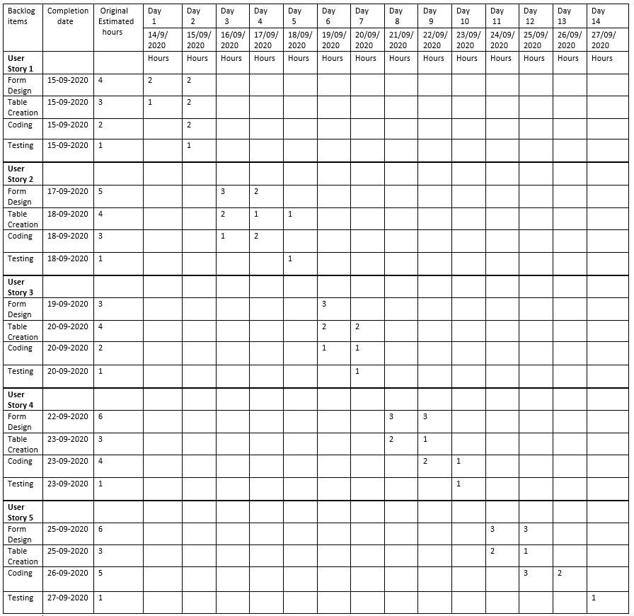

**4.2 SPRINT 2**

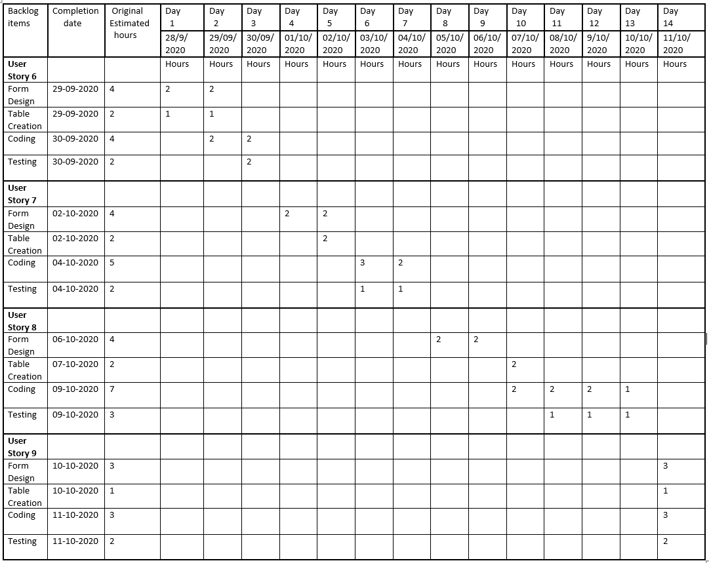

**4.3 SPRINT 3**

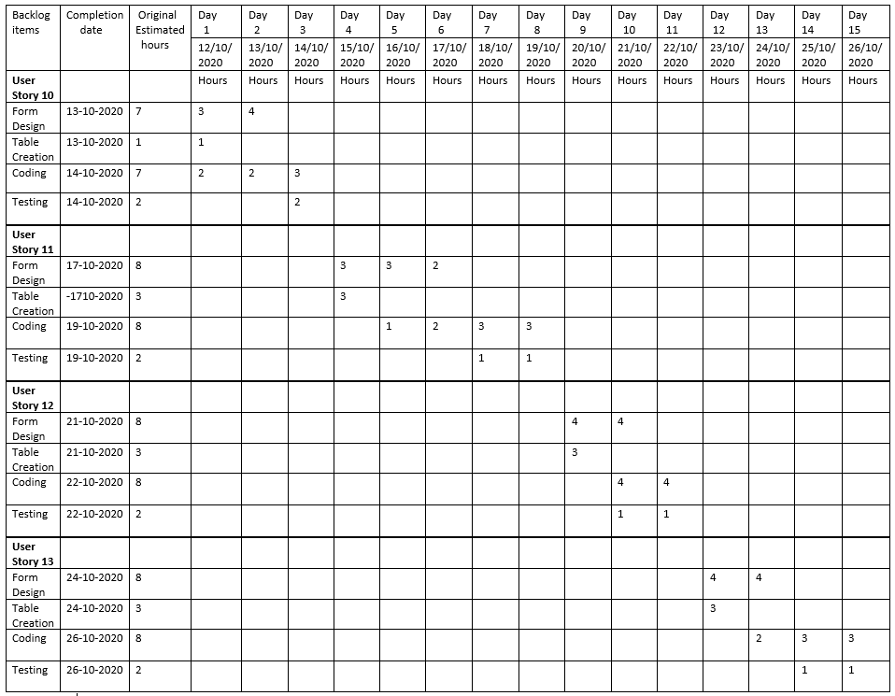

**4.4 SPRINT 4**

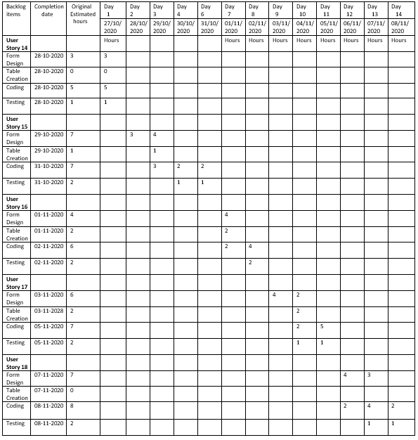

**5. SPRINT BACKLOG ACTUAL**

**5.1 SPRINT 1**

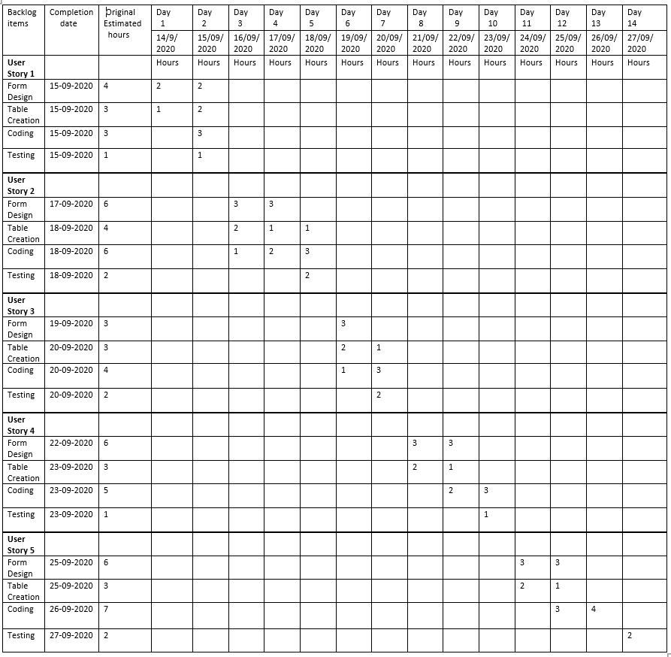

**5.2 SPRINT 2**

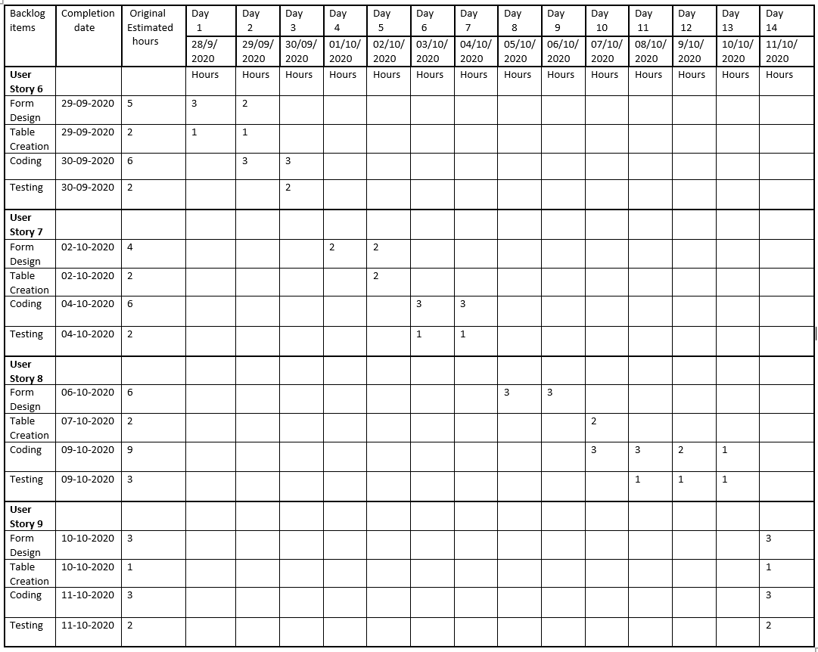

**5.3 SPRINT 3**

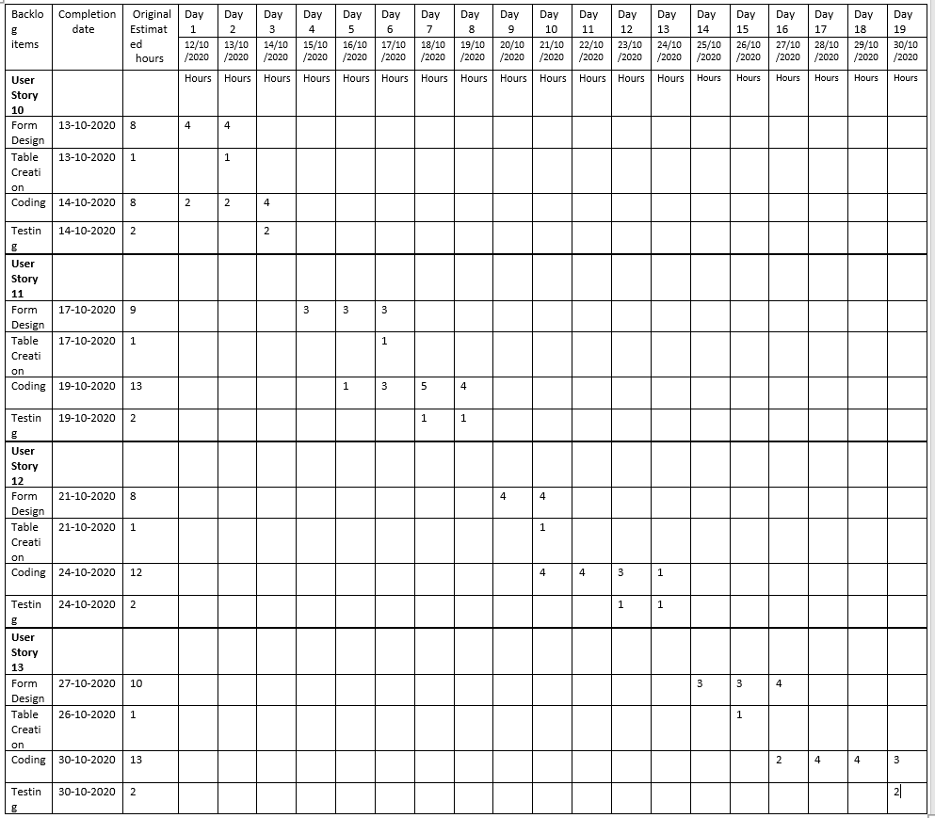

**5.4 SPRINT 4**

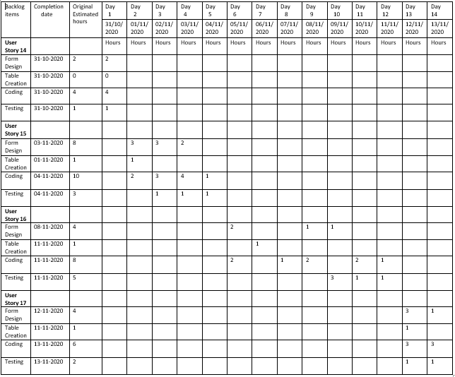

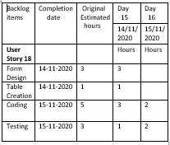

**DATABASE & UI DESIGN**

**1.DATABASE DESIGN**

**LOGIN TABLE**

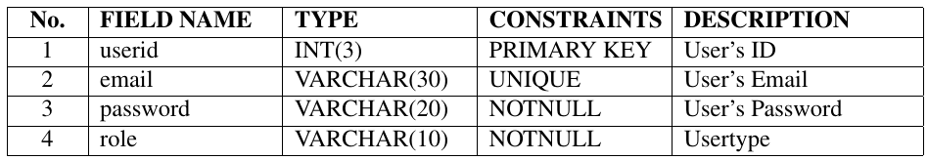

**USER TABLE**

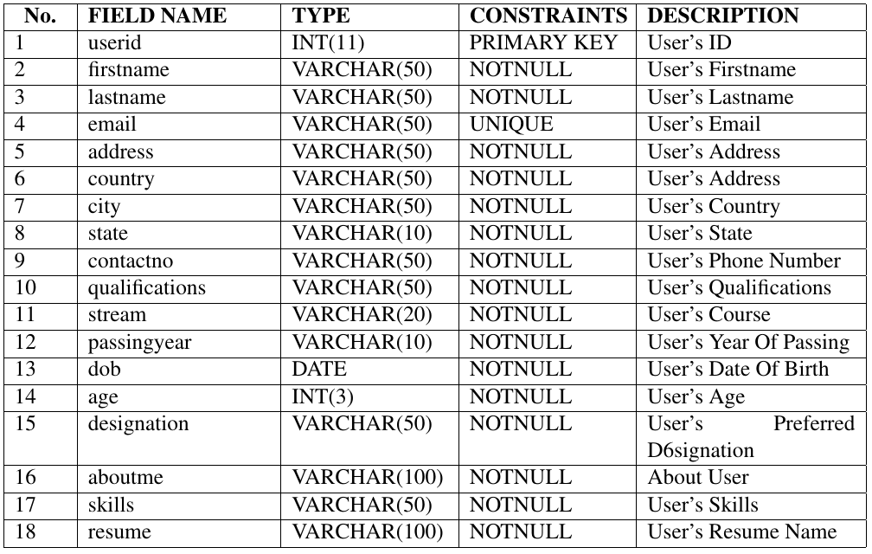

**COMPANY TABLE**

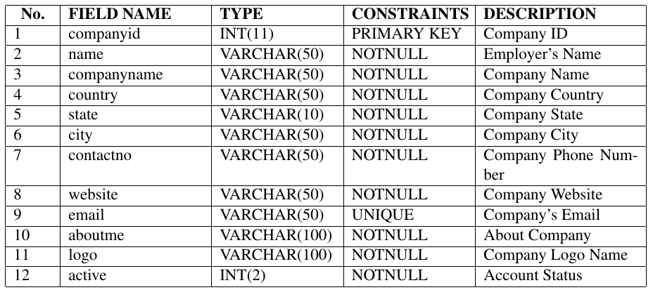

**COUNTRIES TABLE**

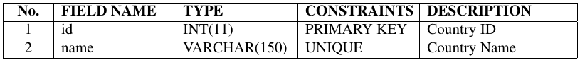

**STATES TABLE**

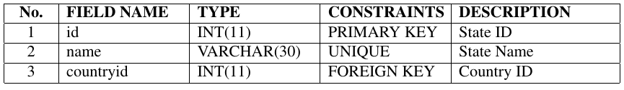

**CITIES TABLE**

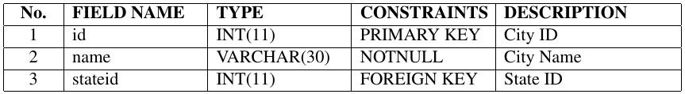

**JOB POST TABLE**

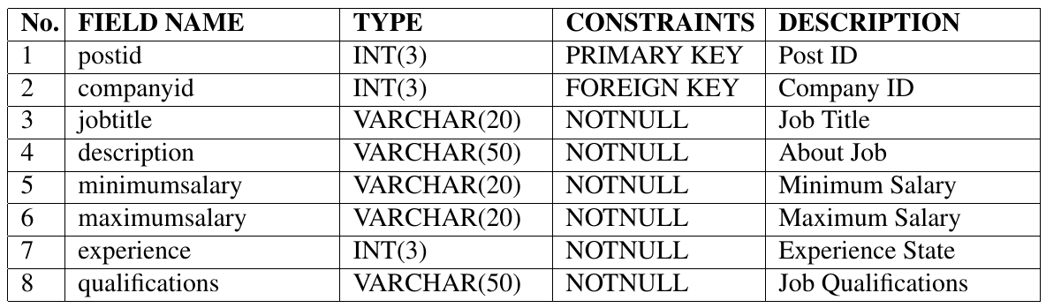

**APPLY JOB POST TABLE**

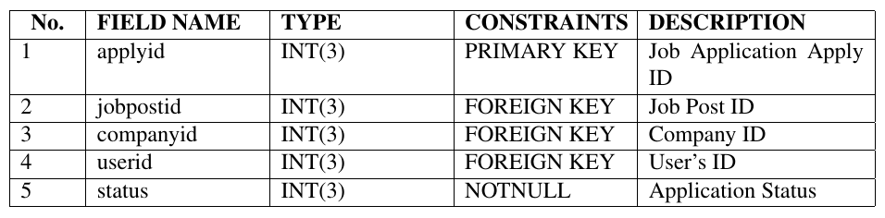

**EXAM TABLE**

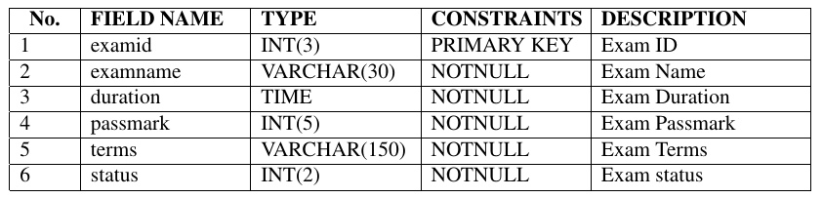

**EXAM QUESTIONS TABLE**

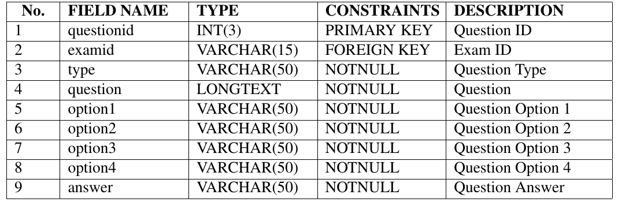

**TASK TABLE**

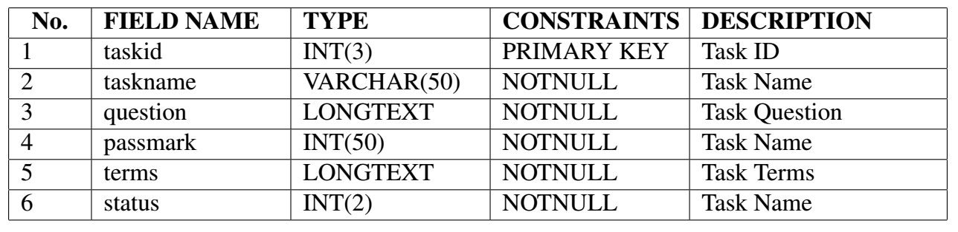

**ASSESSMENT RECORDS**

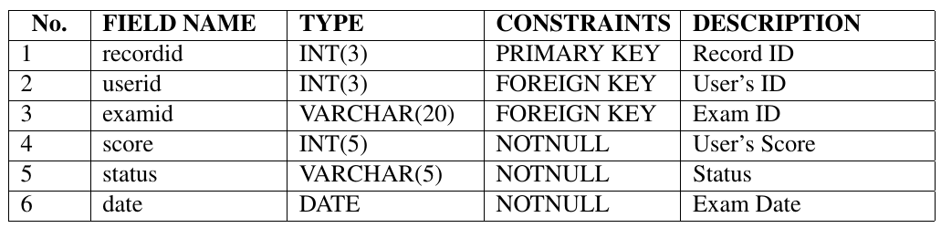

**TASK SUBMIT TABLE**

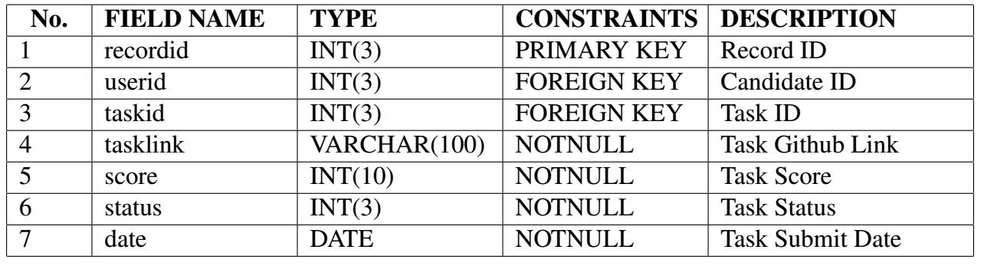

**MAILBOX TABLE**

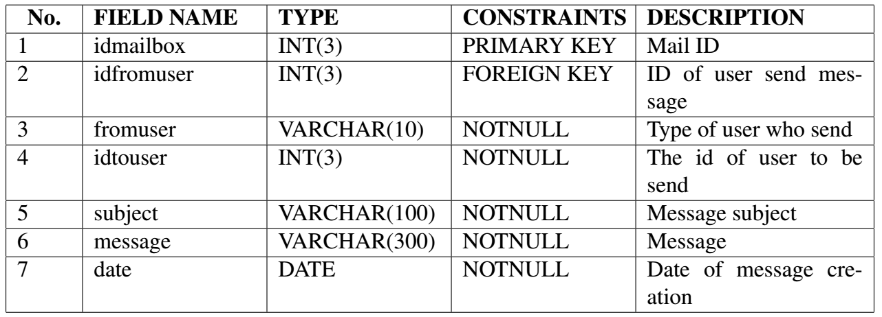

**REPLY MAIL TABLE**

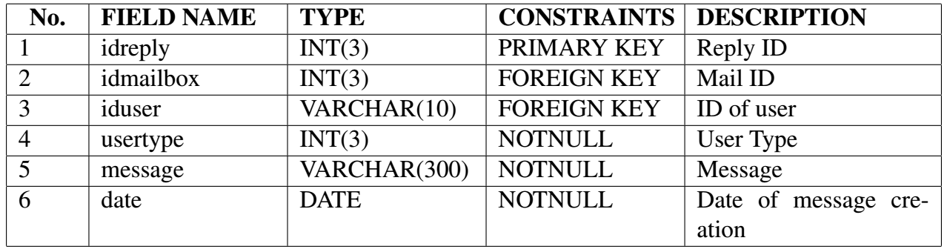

**2 .UI DESIGN**

**HOME PAGE**

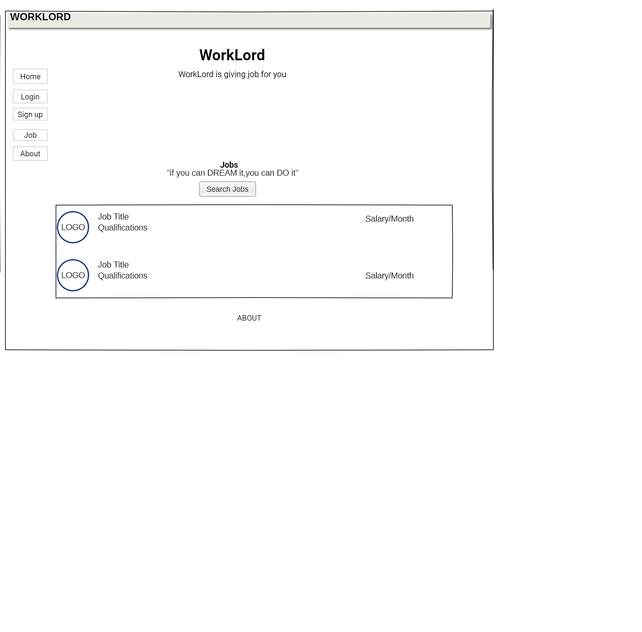

**LOGIN PAGE**

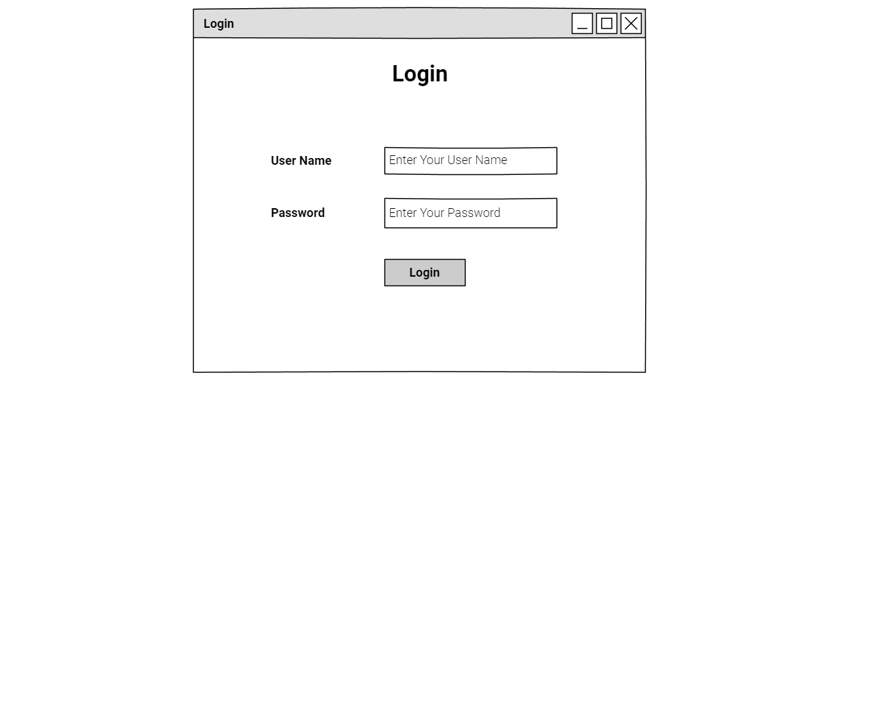

**CANDIDATE REGISTRATION**

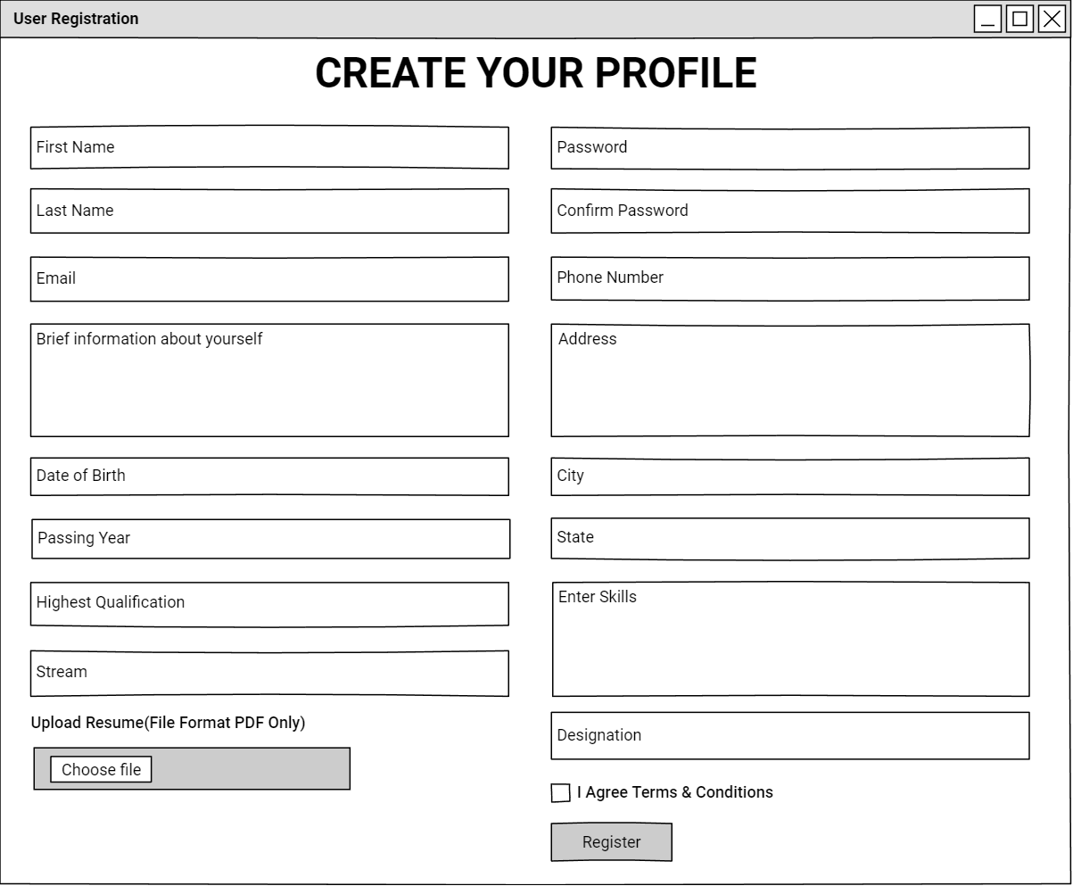

**CANDIDATES HOME PAGE**

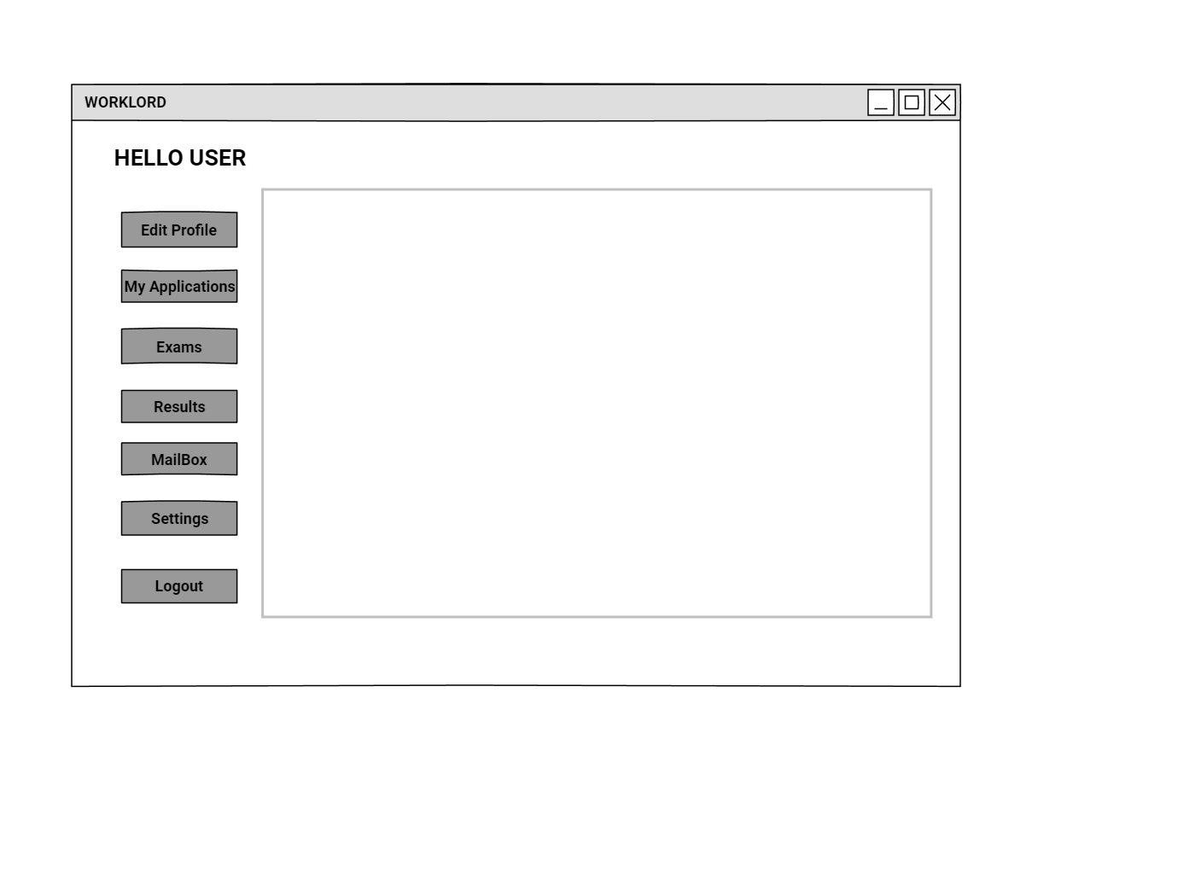

**COMPANY REGISTRATION**

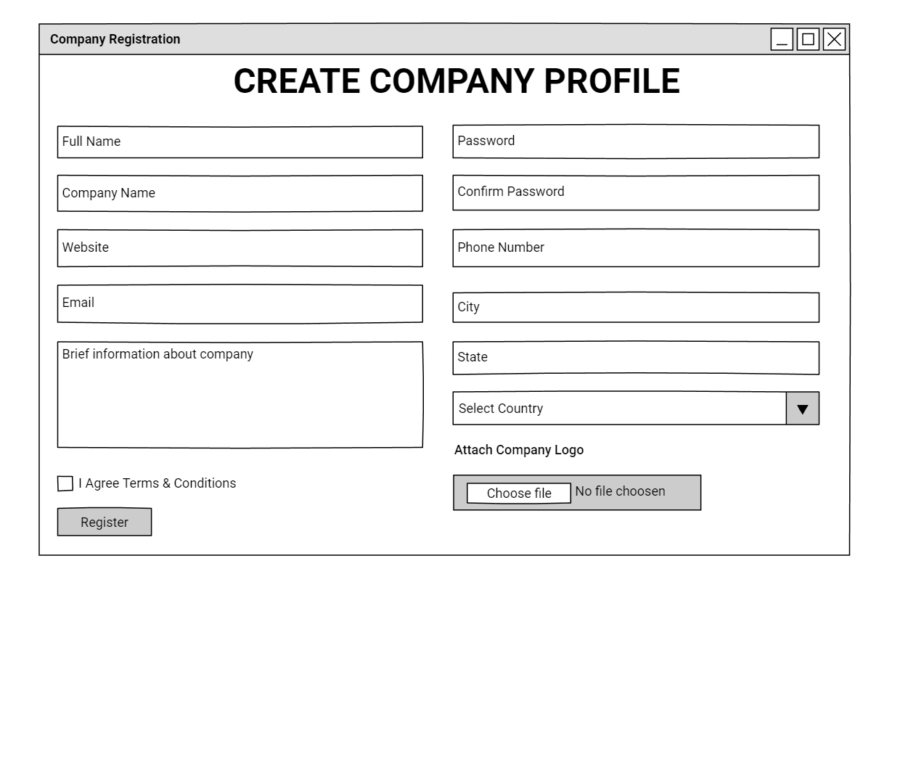

**COMPANY HOME PAGE**

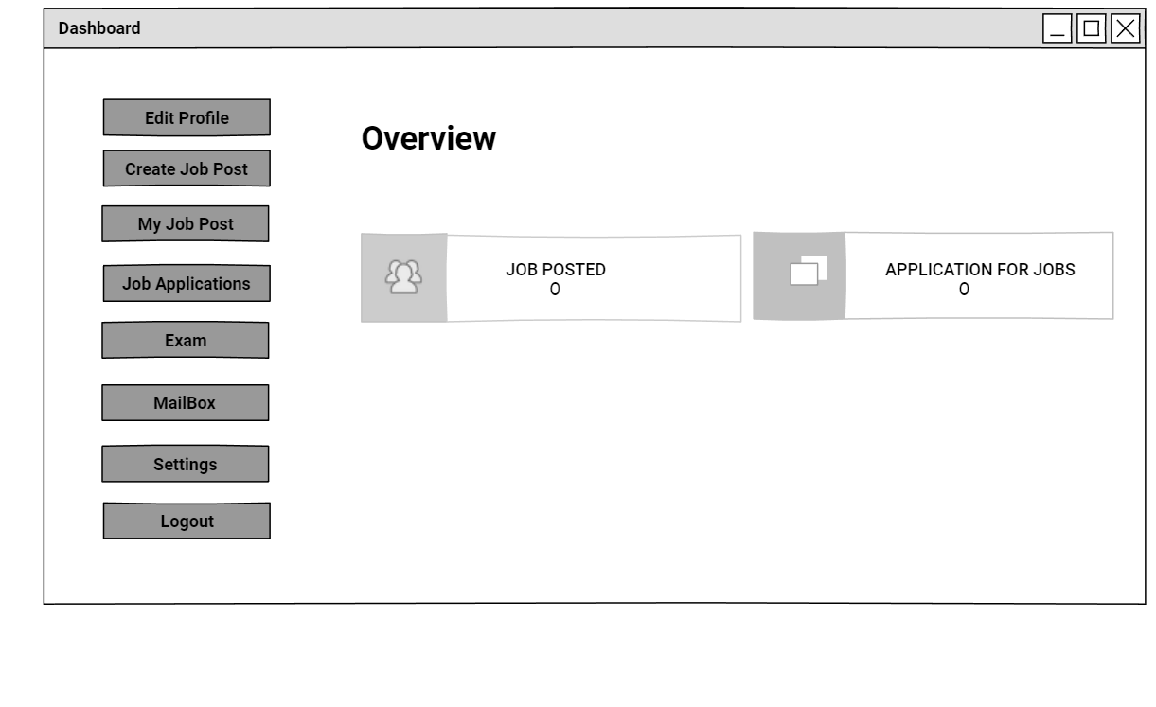

**ADMIN HOME PAGE**

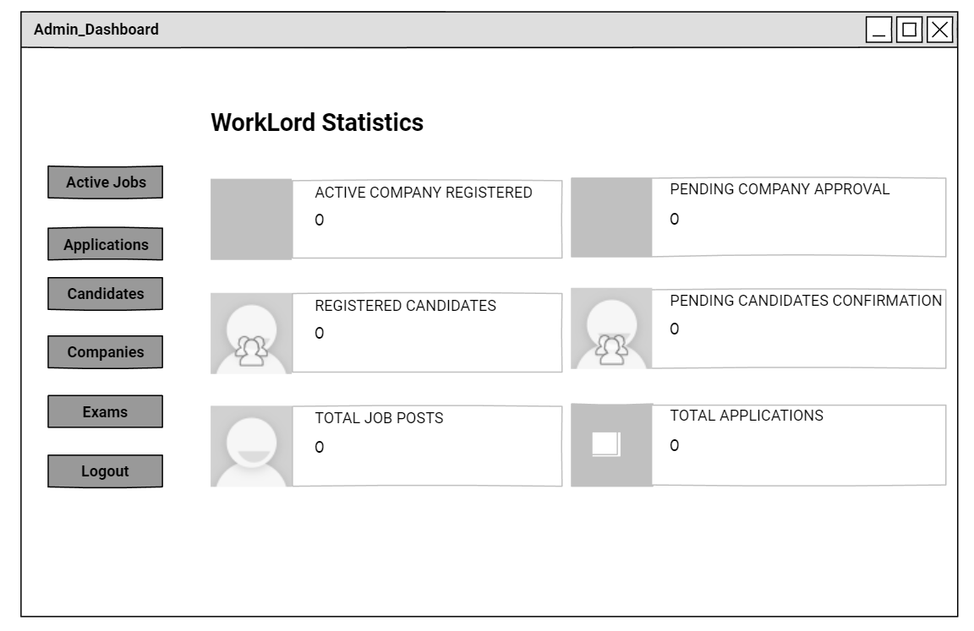

**ADMIN APPROVE/DISAPPROVE COMPANY**

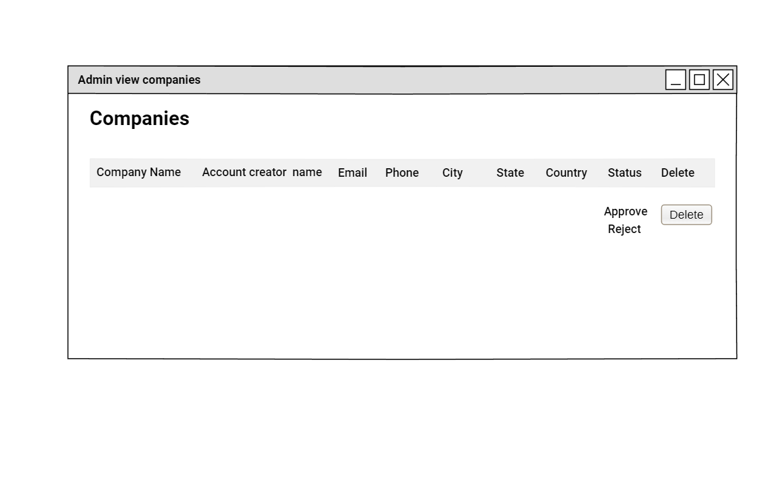

**CREATE JOB POST**

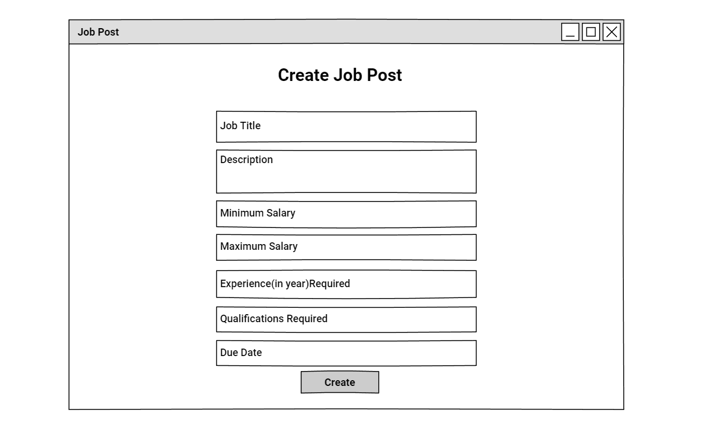

**ACTIVE JOB POST**

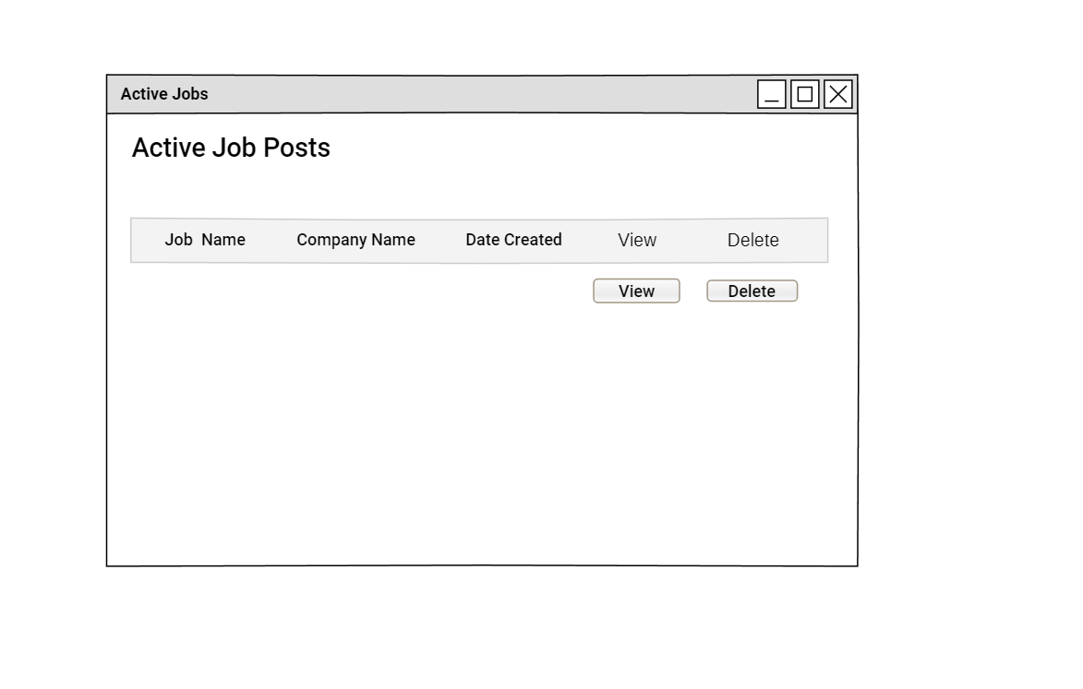

**USER SEARCH JOBS**

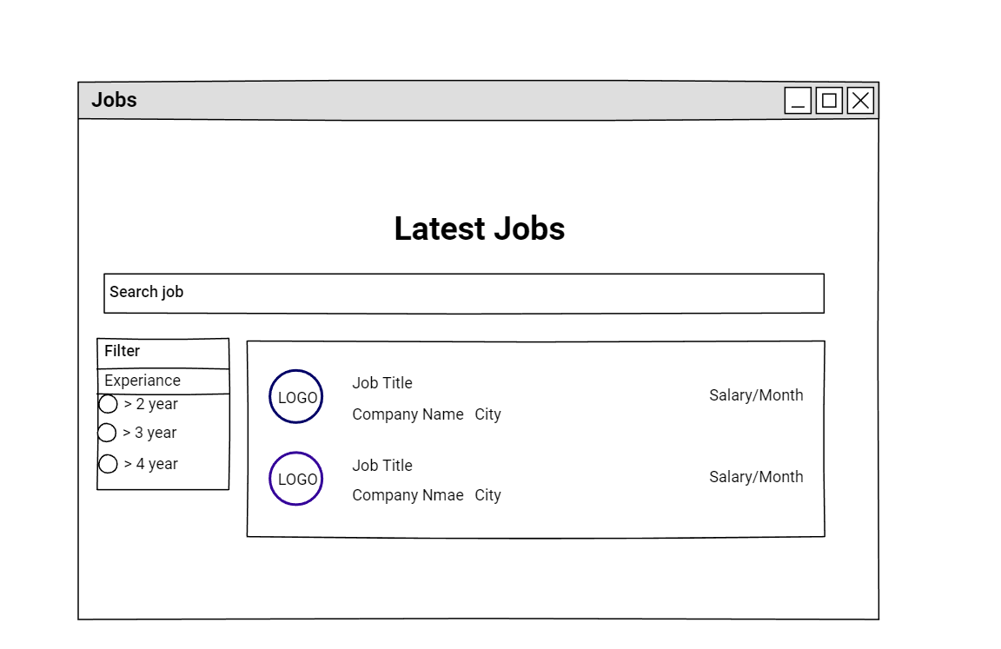

**USER APPLY JOBS**

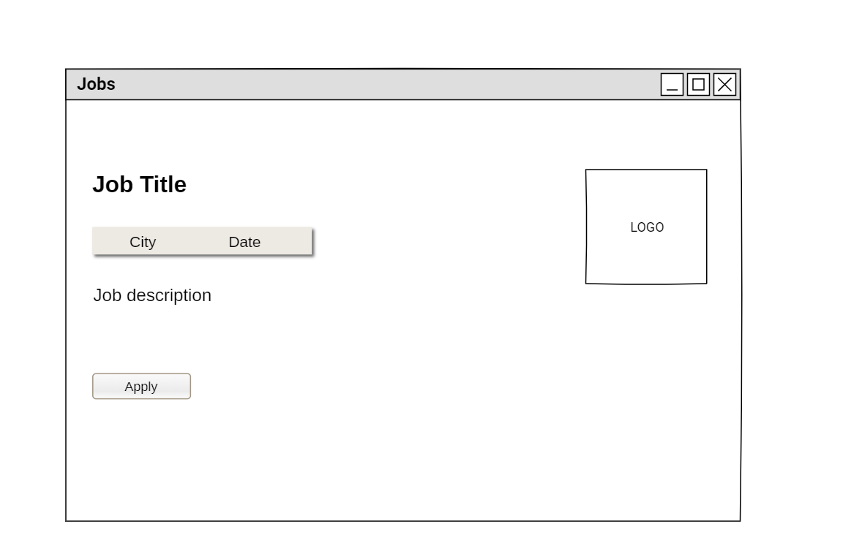

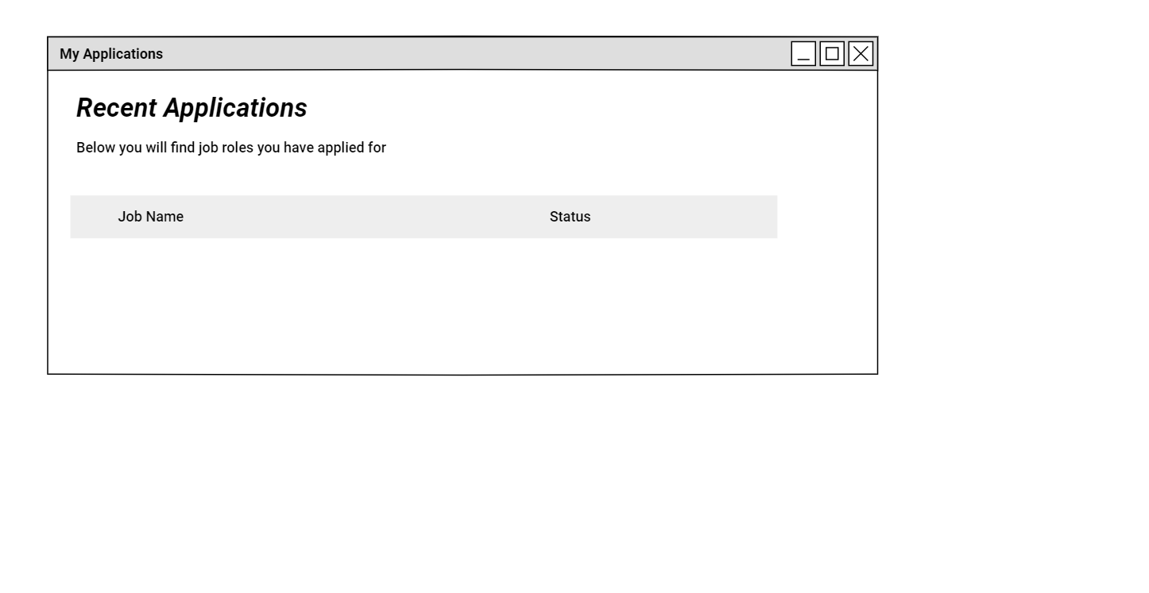**VIEW APPLIED JOBS POST**

**VIEW POSTED JOBS**

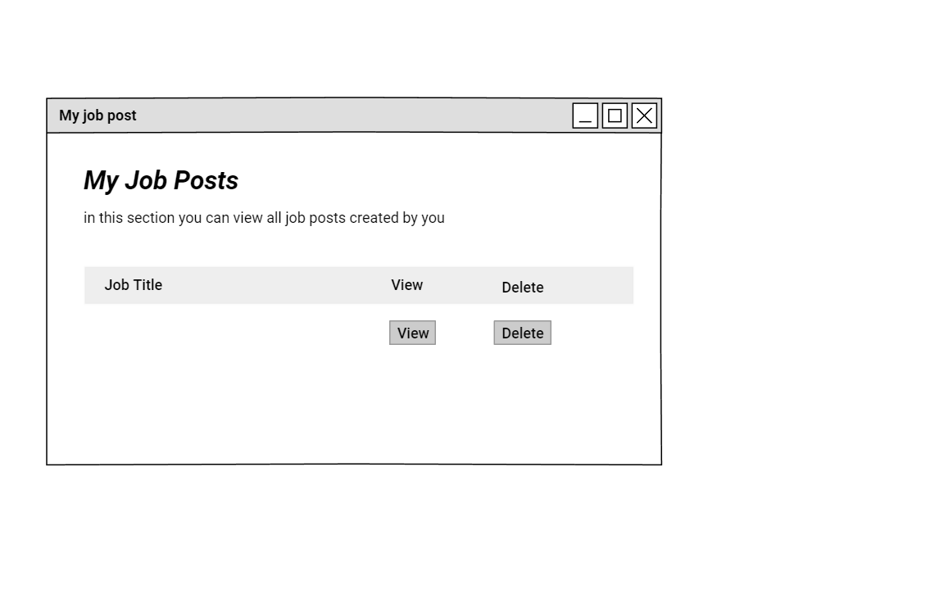

**VIEW JOB APPLICATIONS**

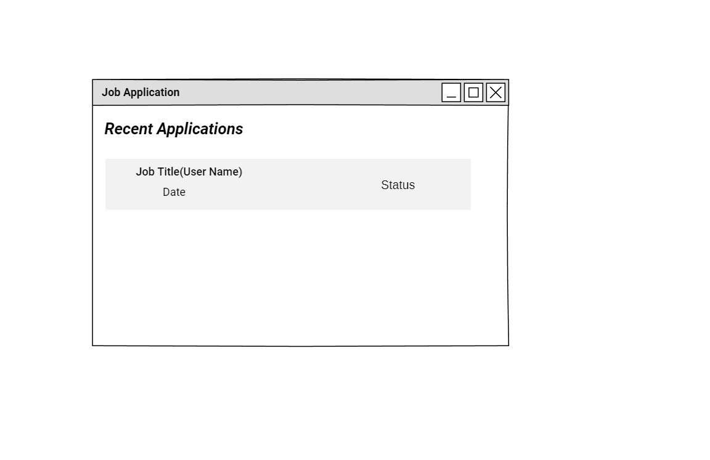

**DOWNLOAD RESUME**

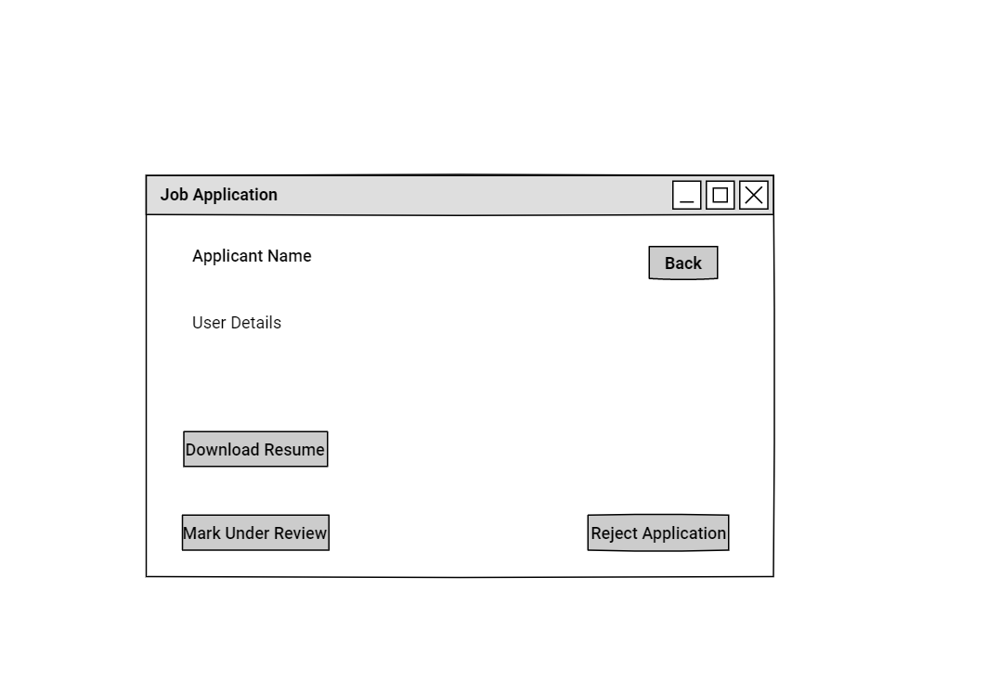

**EXAM DASHBOARD**

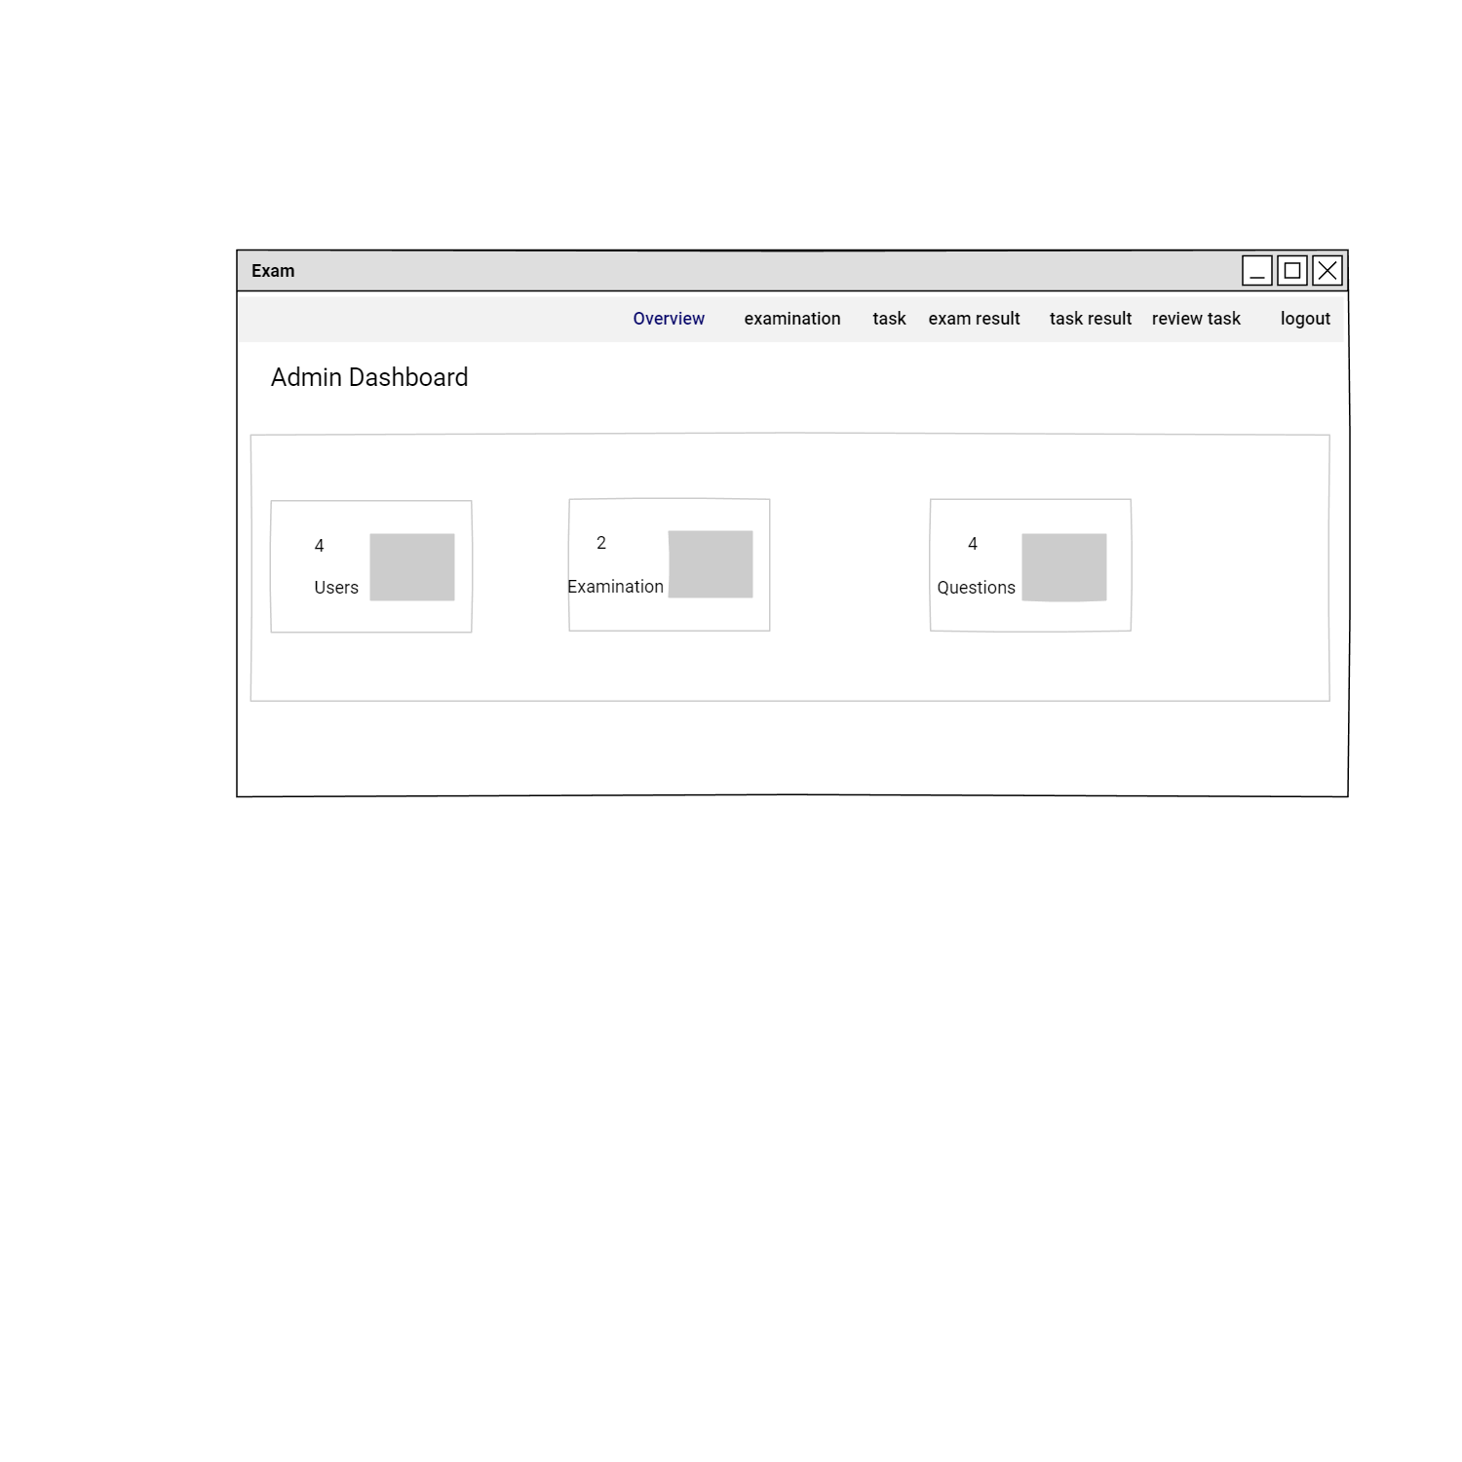

**VIEW EXAMS**

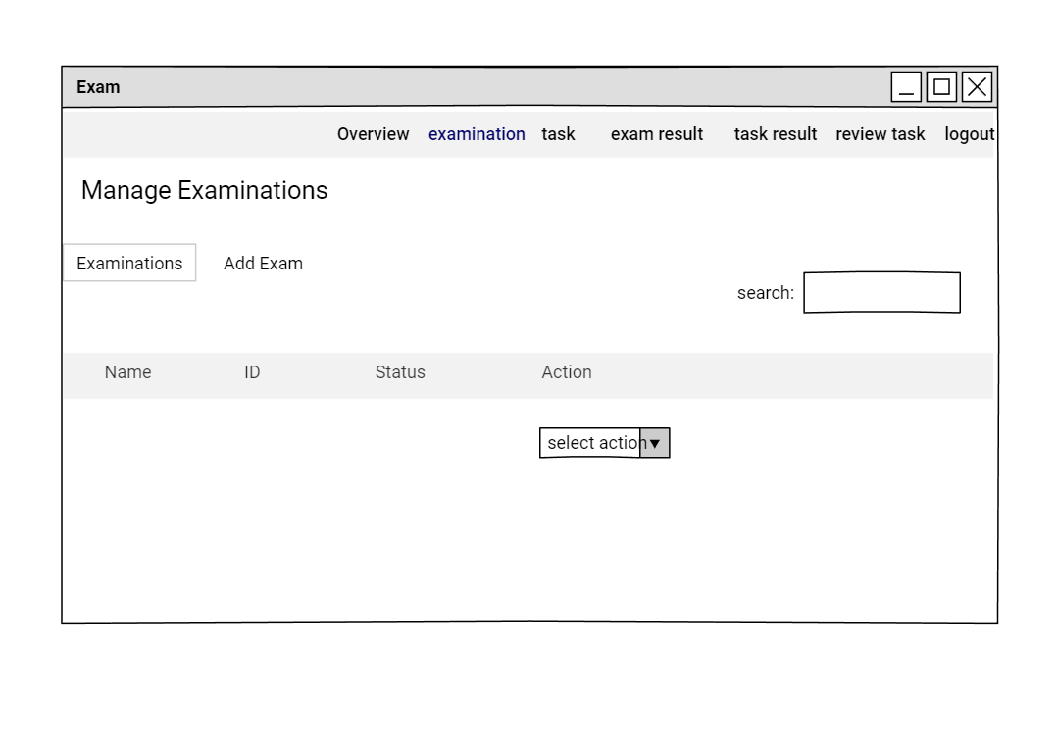

**ADD NEW EXAM**

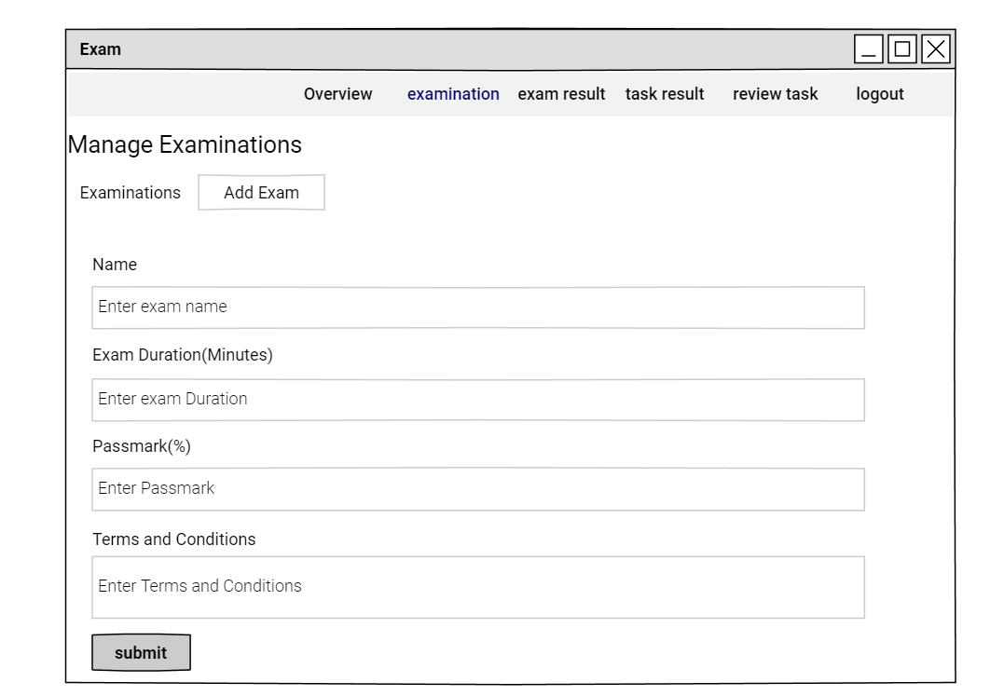

**ADD EXAM QUESTIONS**

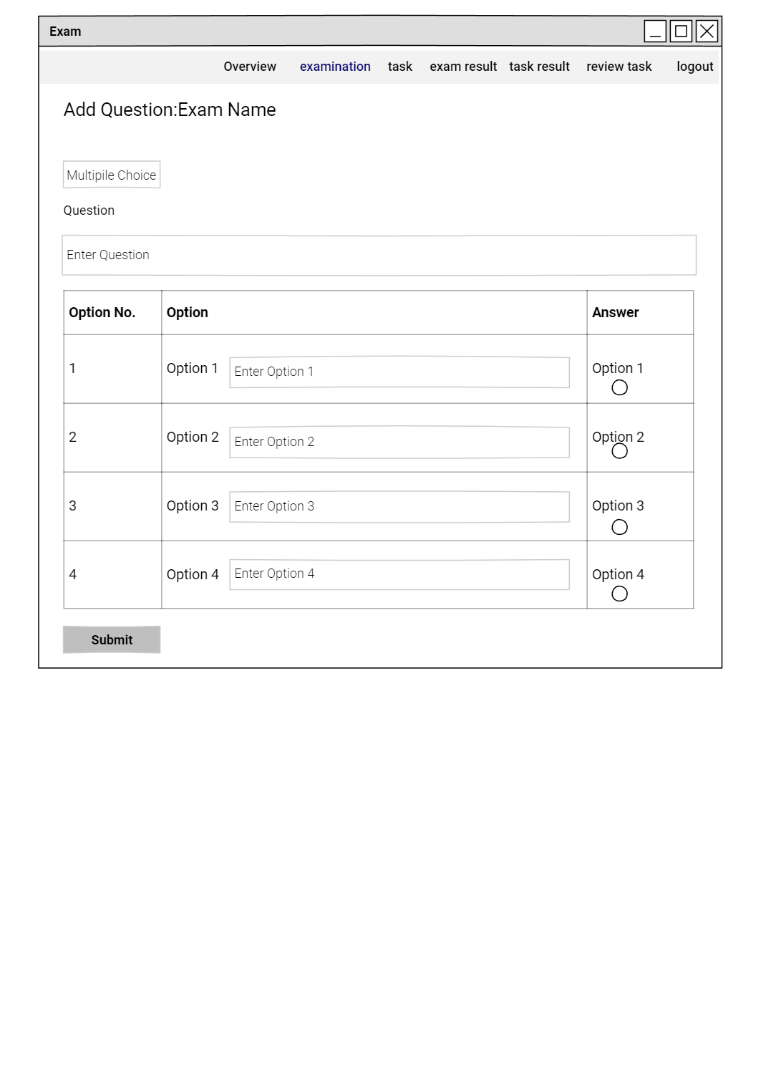

**VIEW EXAM QUESTIONS**

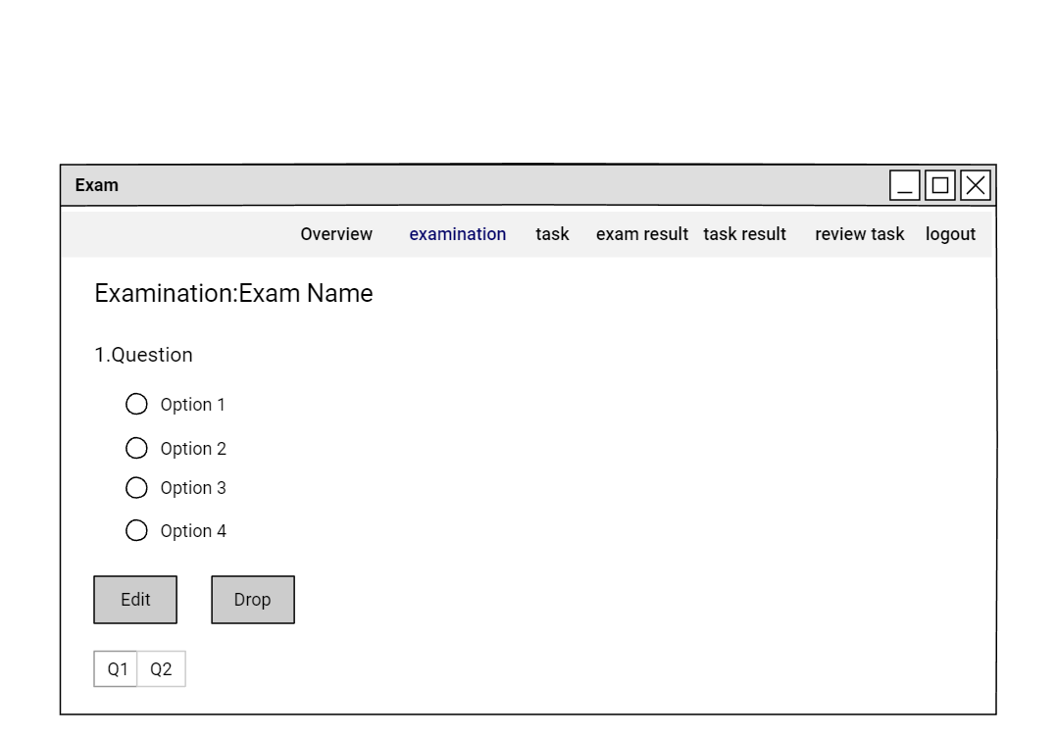

**VIEW TASKS**

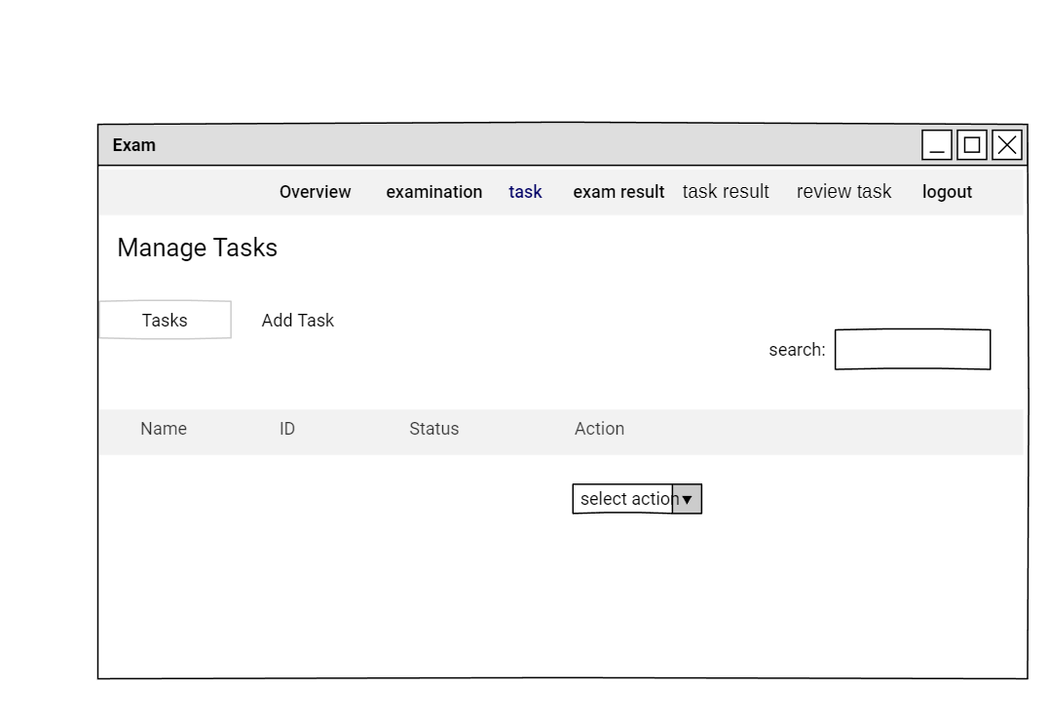

**CREATE NEW TASK**

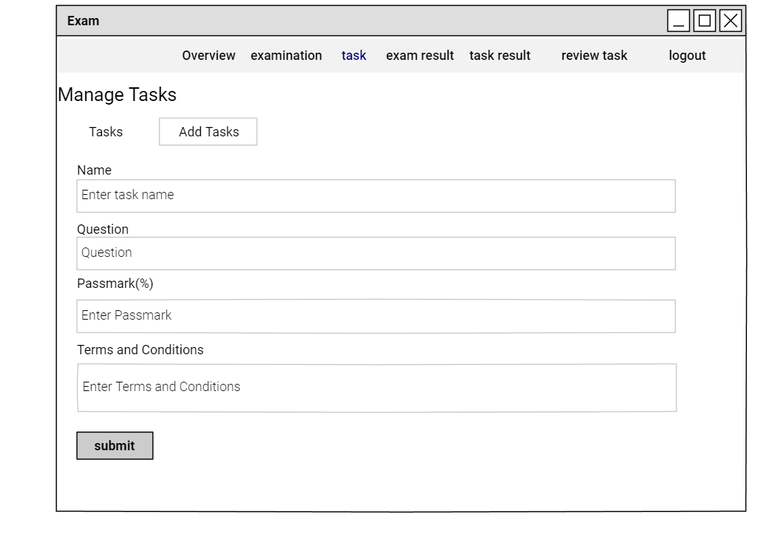

**VIEW TASK QUESTIONS**

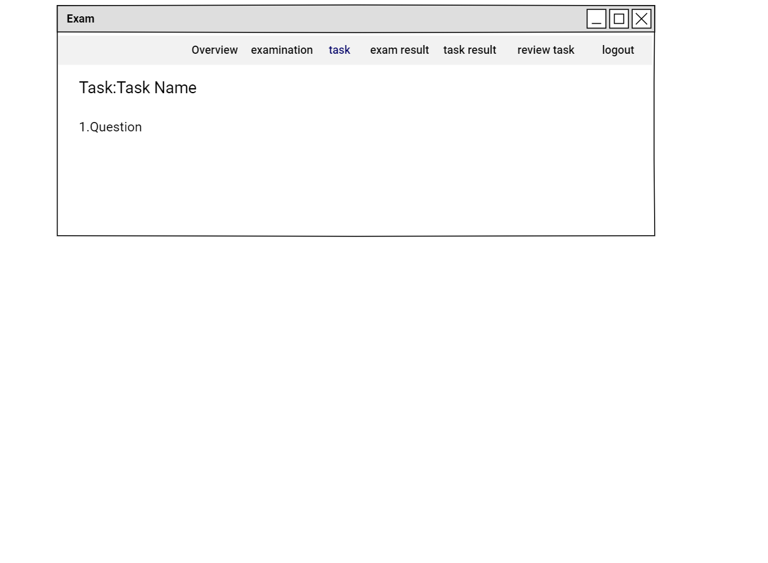

**USER EXAM OVERVIEW**

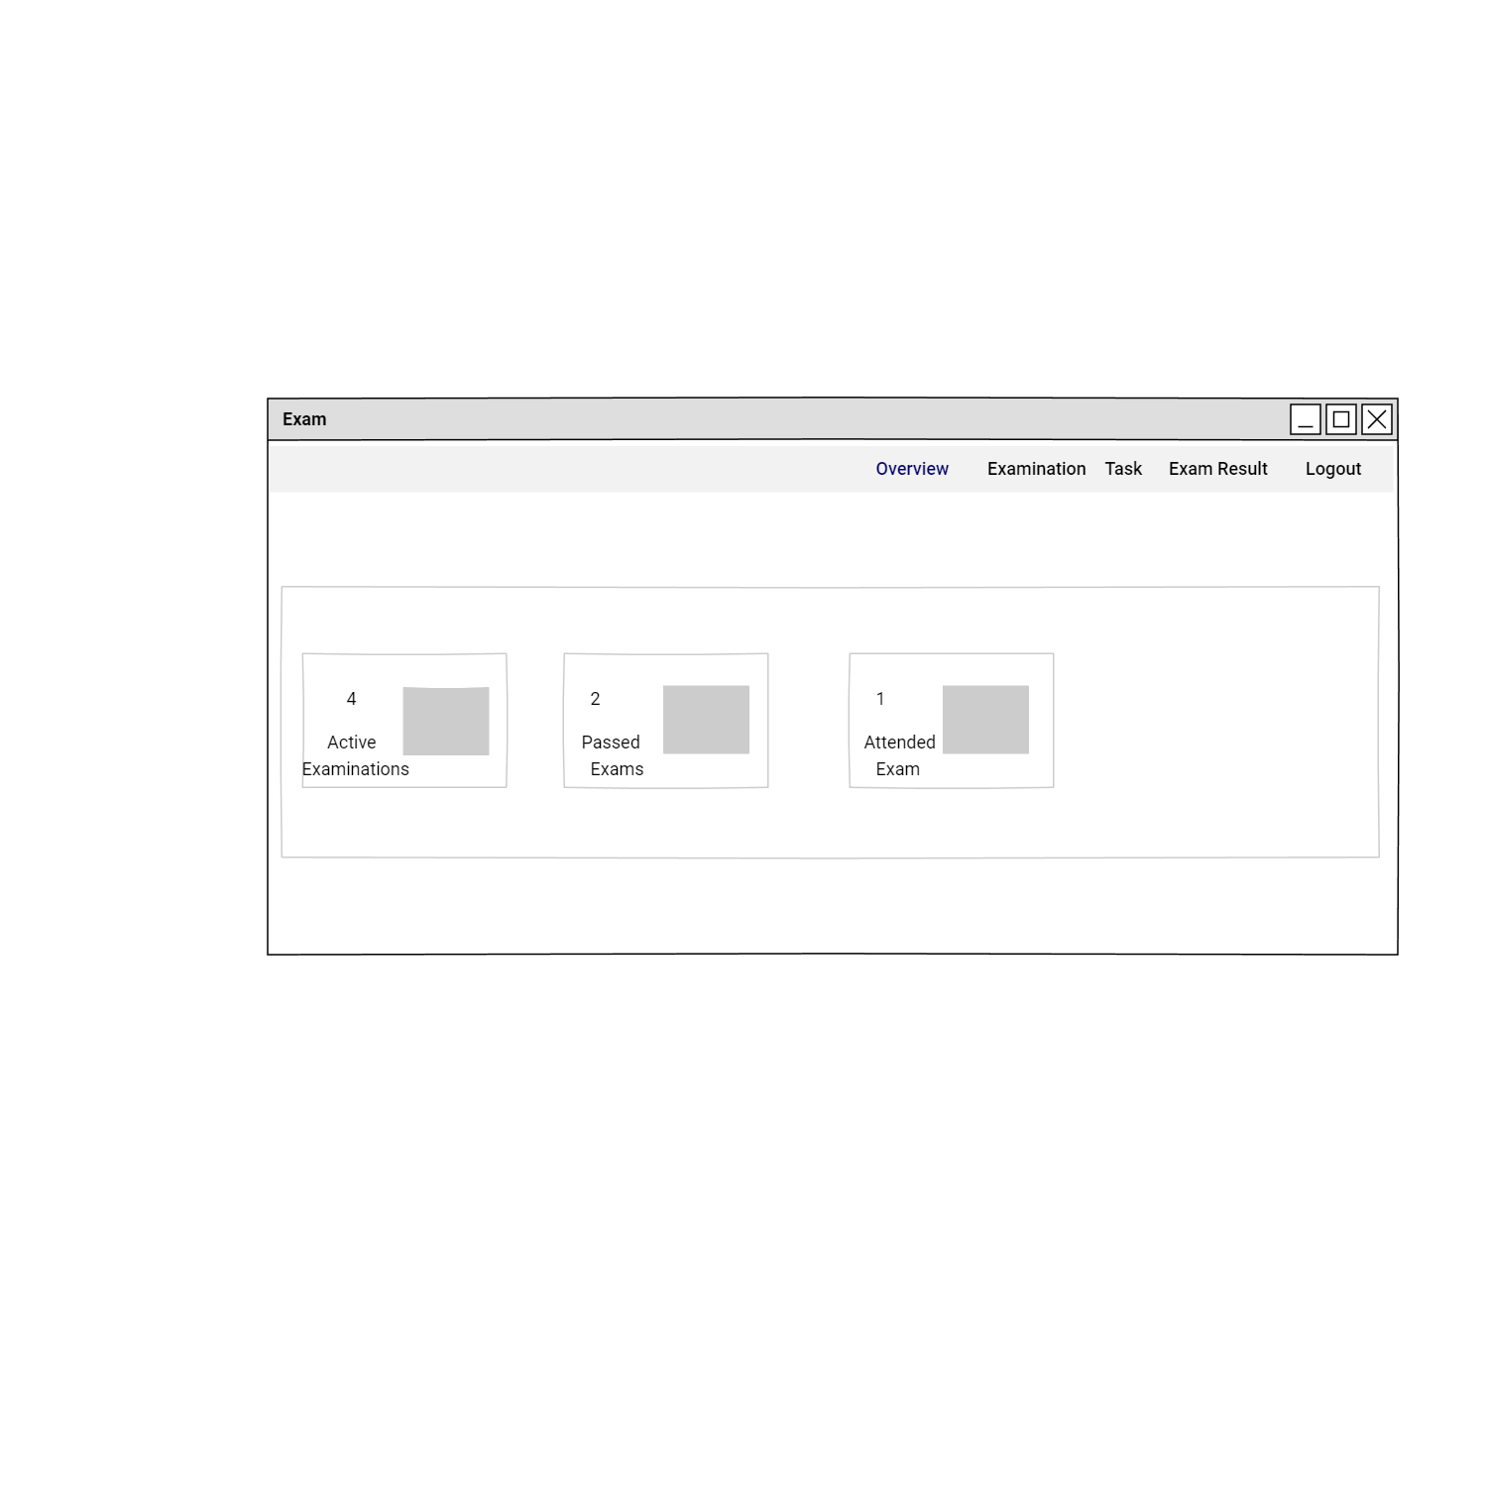

**USER VIEW EXAMS**

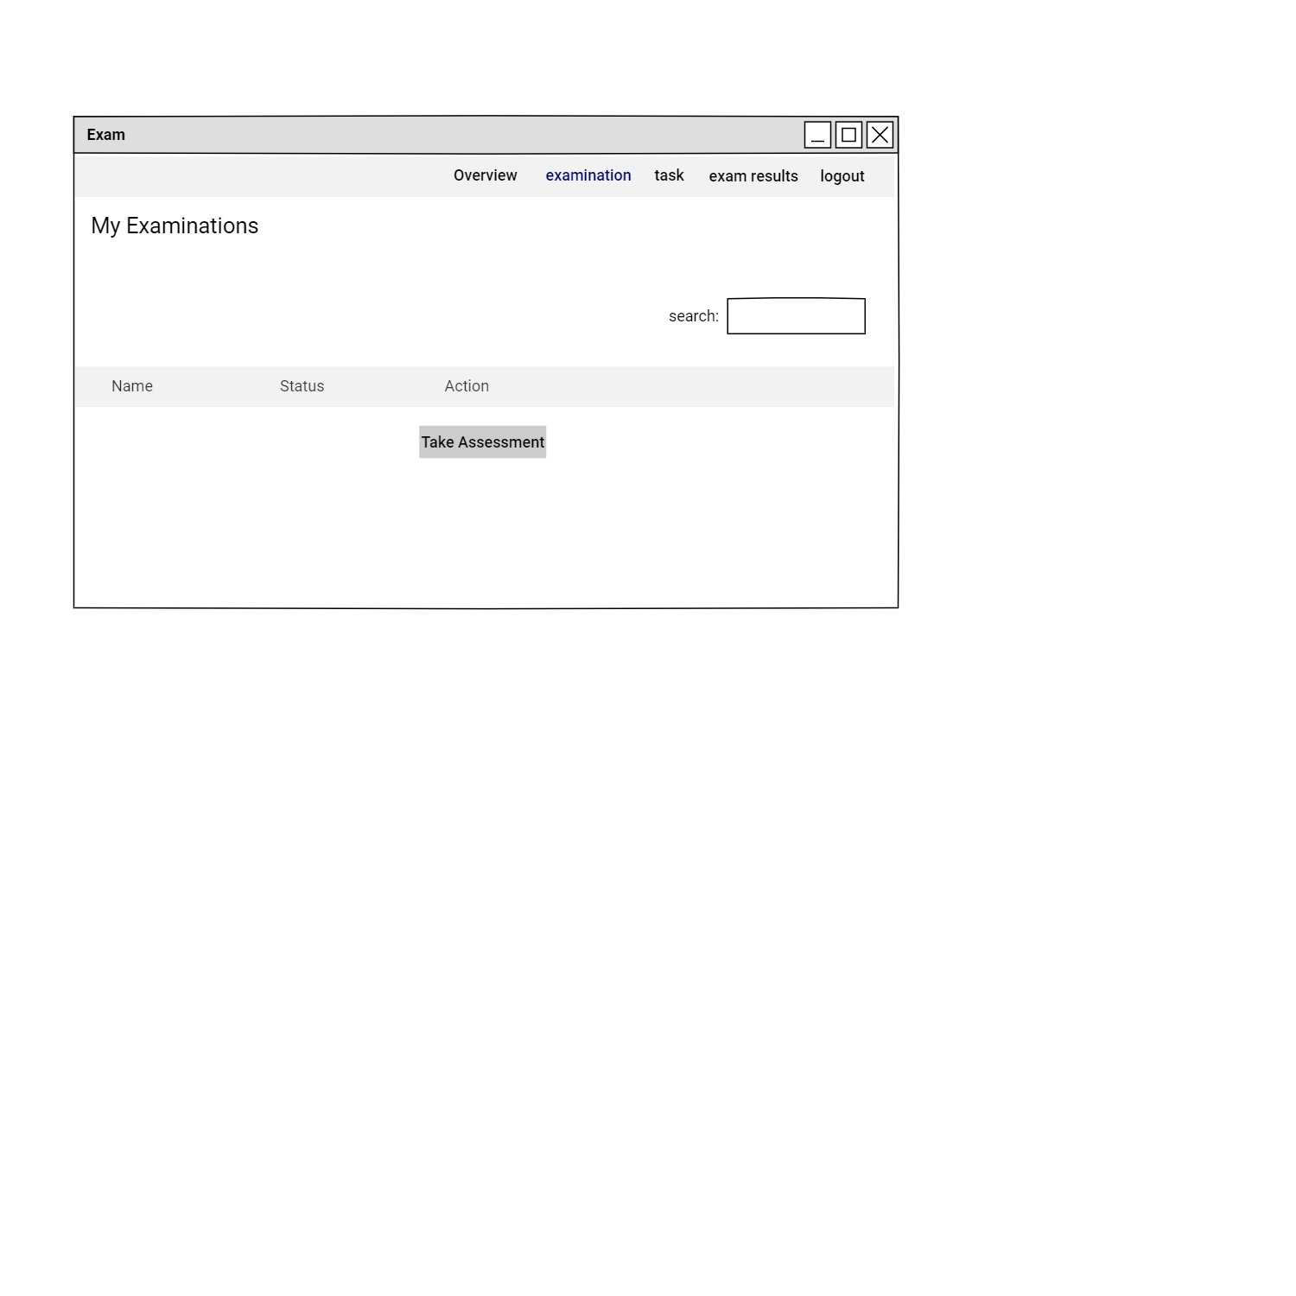

**TAKE ASSESSMENT**

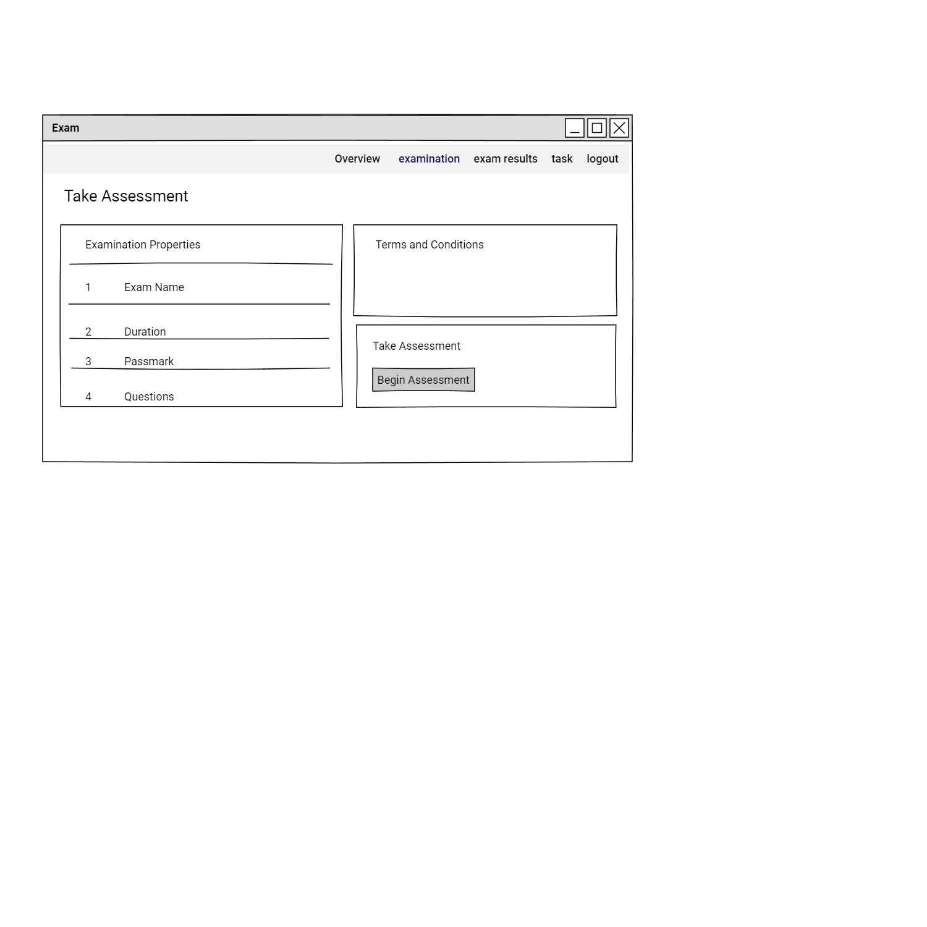

**ATTEND EXAM**

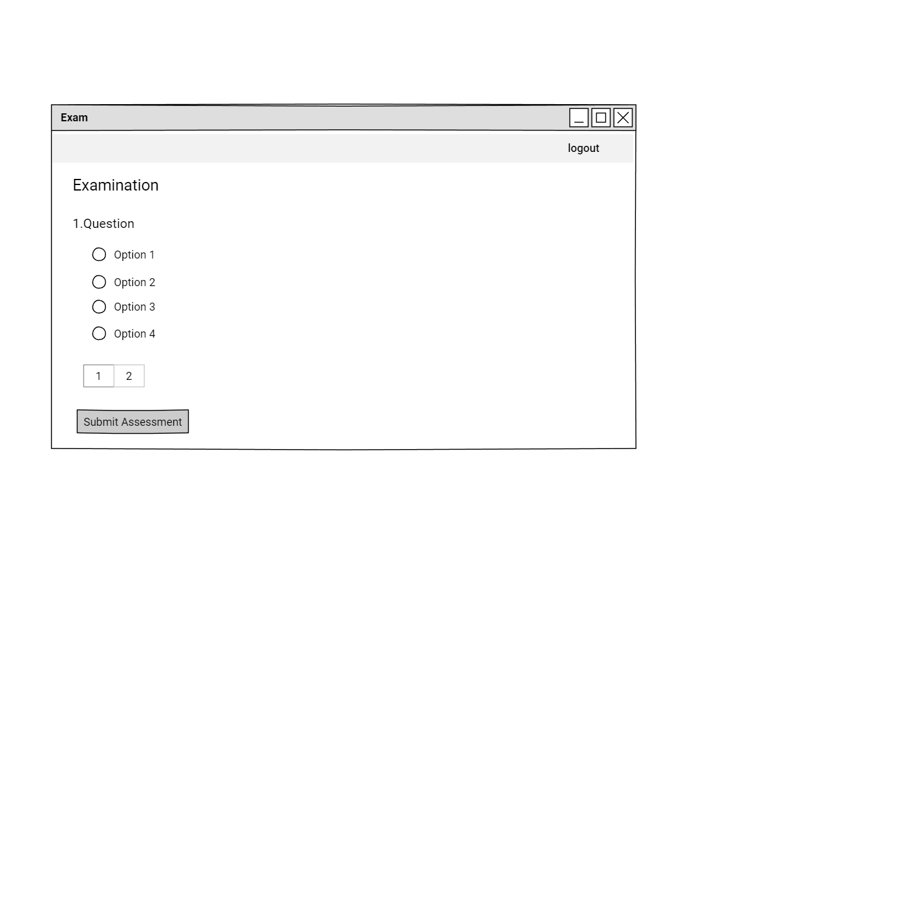

**VIEW REGISTERED CANDIDATES**

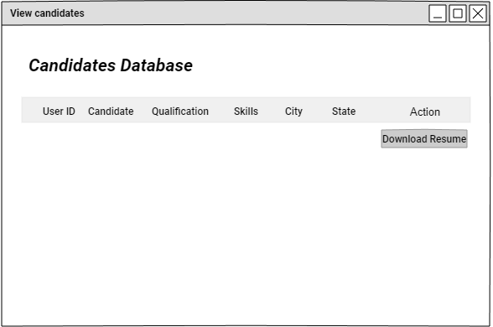

**USER VIEW TASKS**

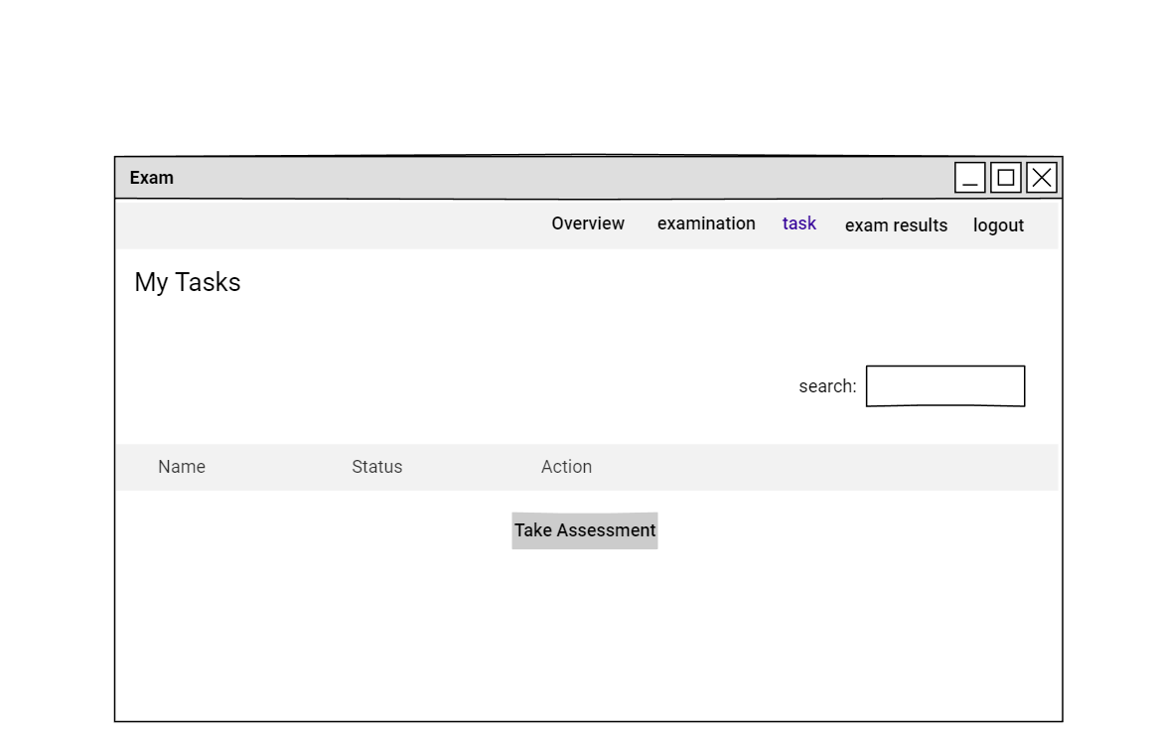

**USER SUBMIT TASKS**

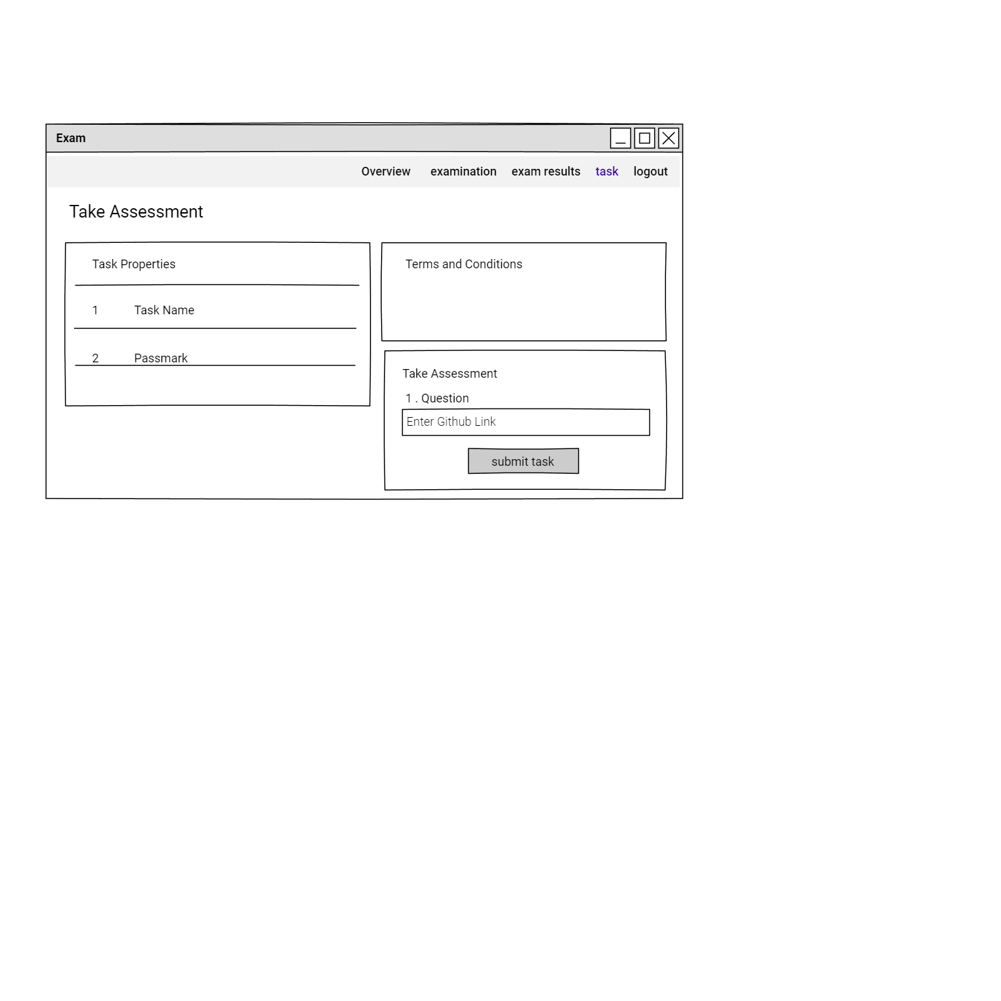

**VIEW MESSAGES**

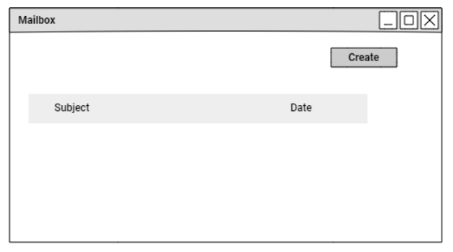

**CREATE MESSAGE**

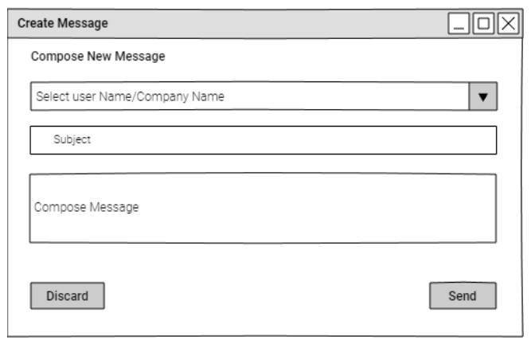

**REPLY MESSAGE**

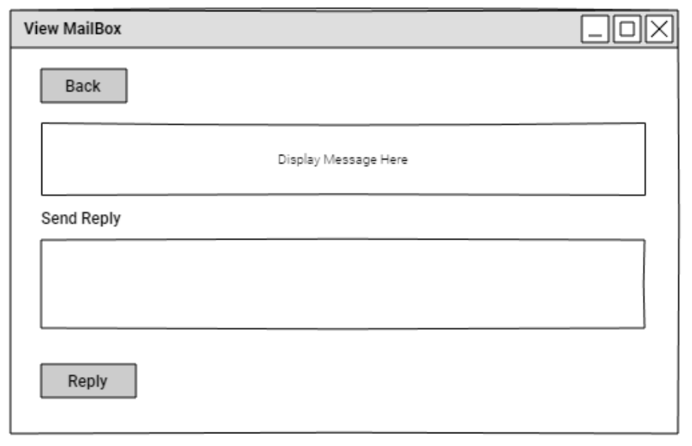

**UPDATE COMPANY PROFILE**

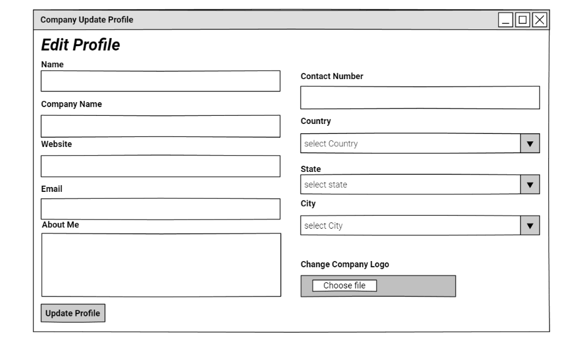

**COMPANY CHANGE PASSWORD**

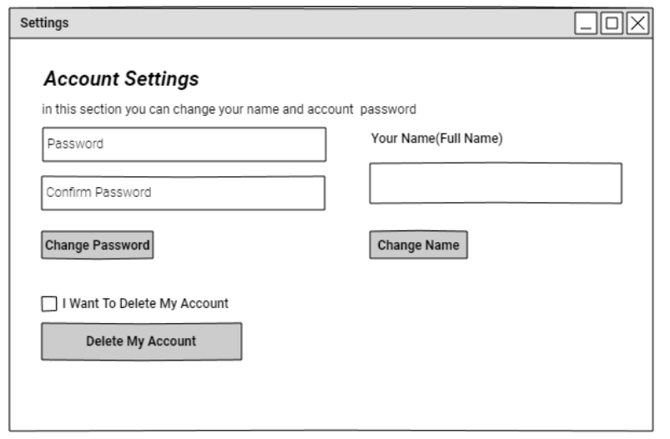

**UPDATE CANDIDATE PROFILE**

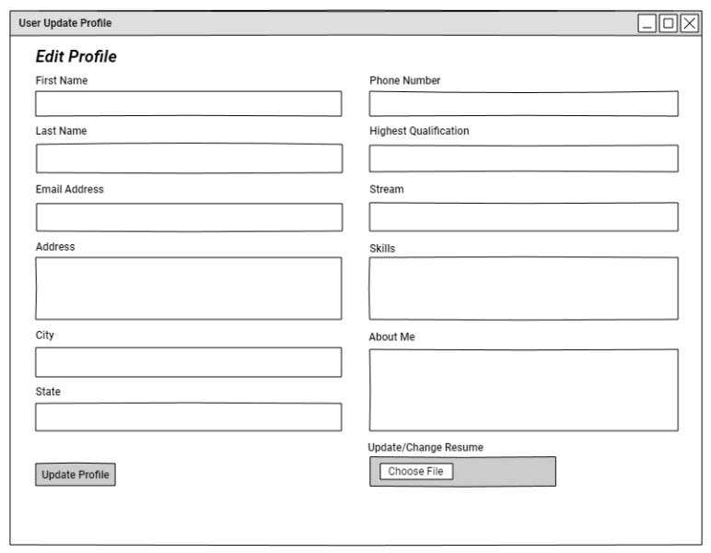

**CANDIDATE CHANGE PASSWORD**

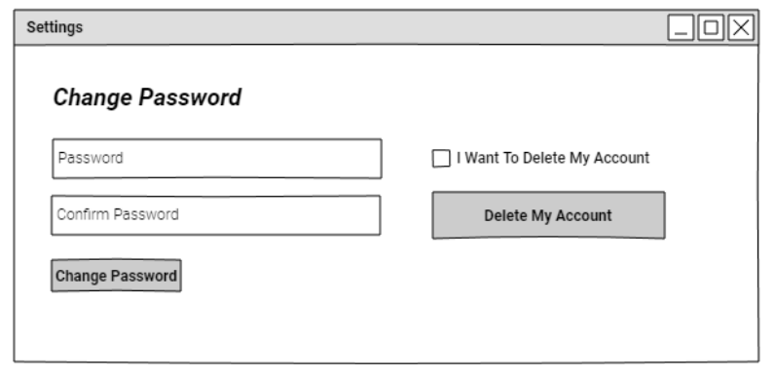

**ADMIN VIEW EXAMS RESULTS**

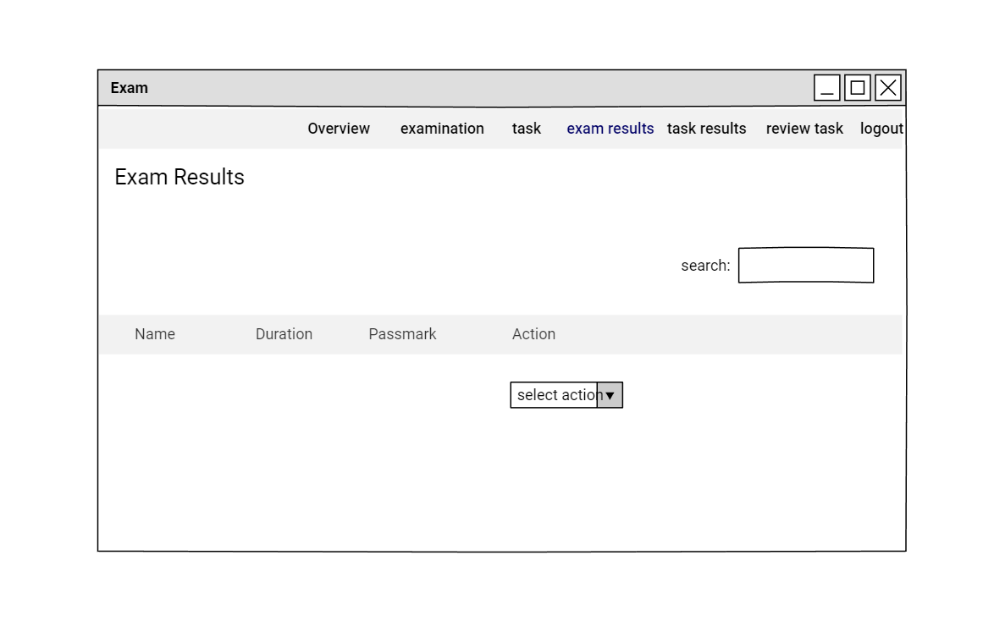

**ADMIN VIEW PARTICULAR EXAM RESULTS**

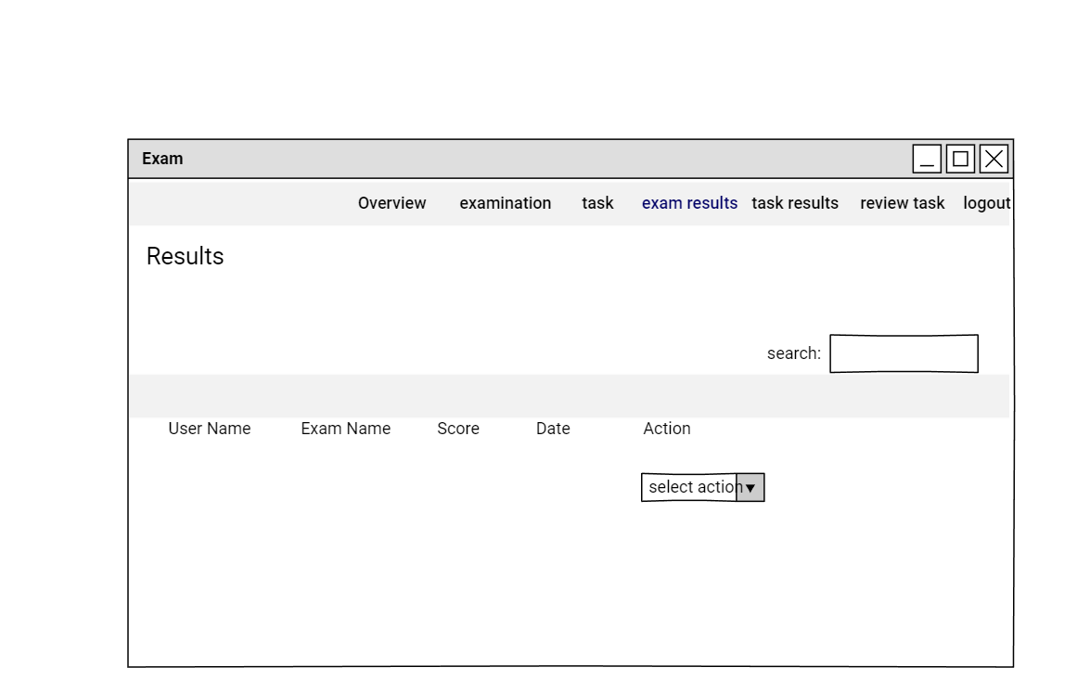

**ADMIN VIEW TASKS RESULTS**

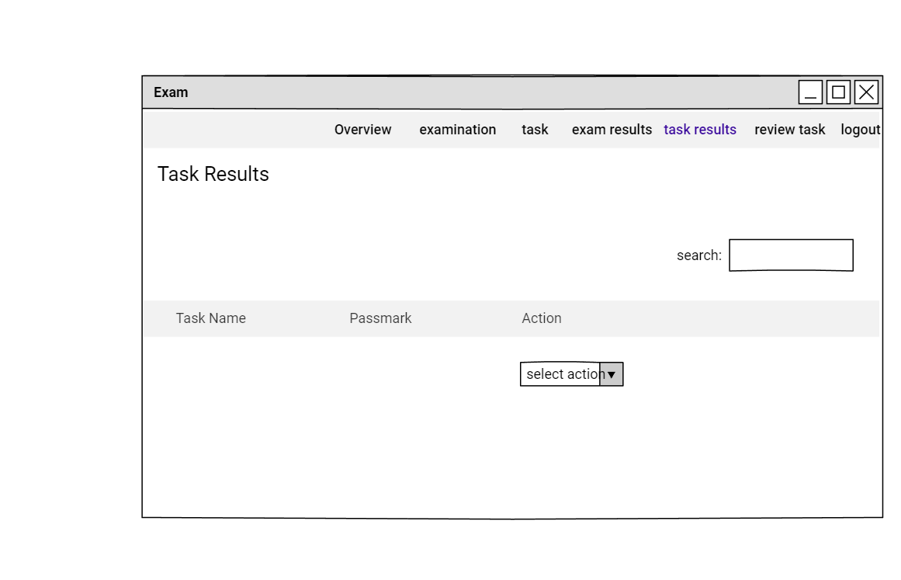

**ADMIN VIEW PARTICULAR TASK RESULTS**

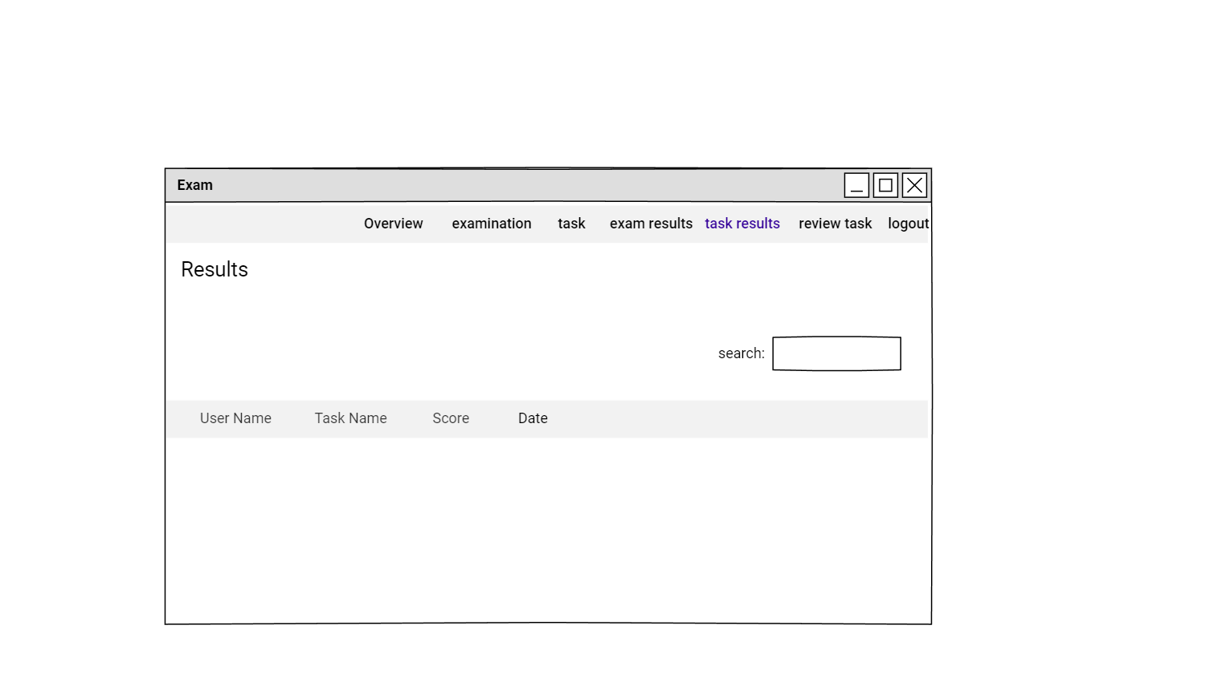

**ADMIN VIEW TASKS FOR REVIEW**

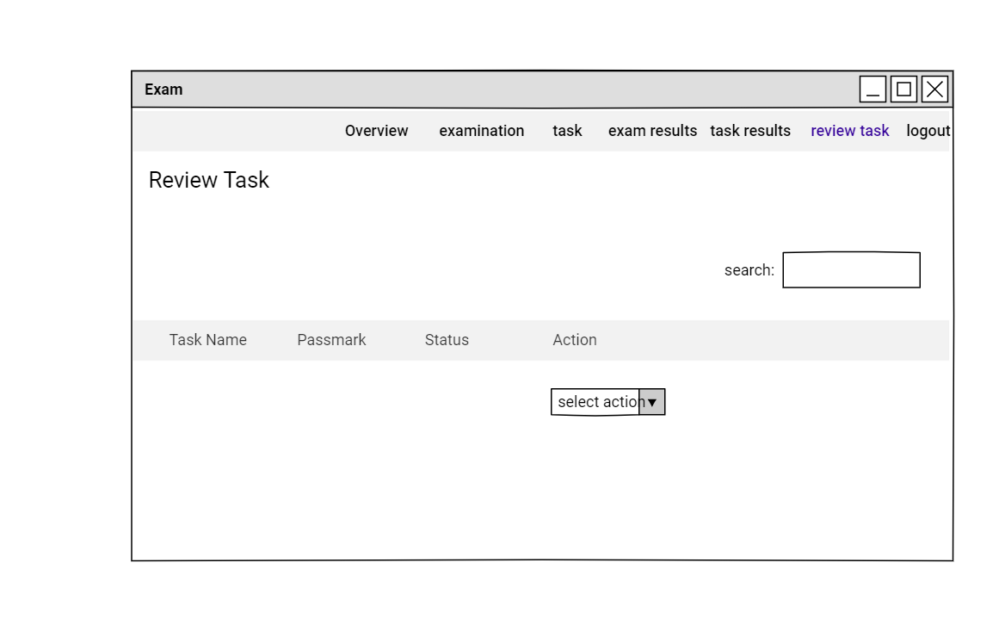

**REVIEW TASK**

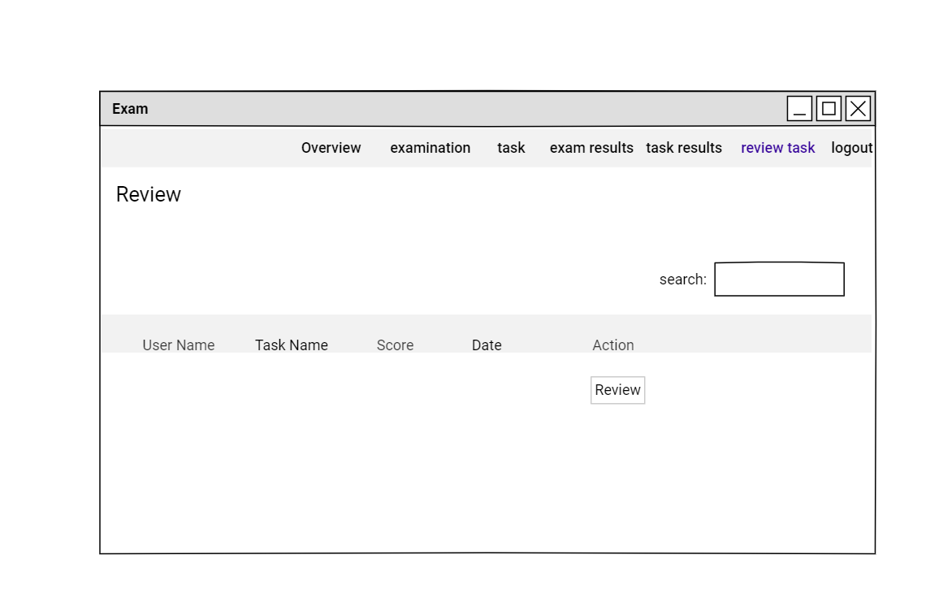

**ENTER TASK SCORE**

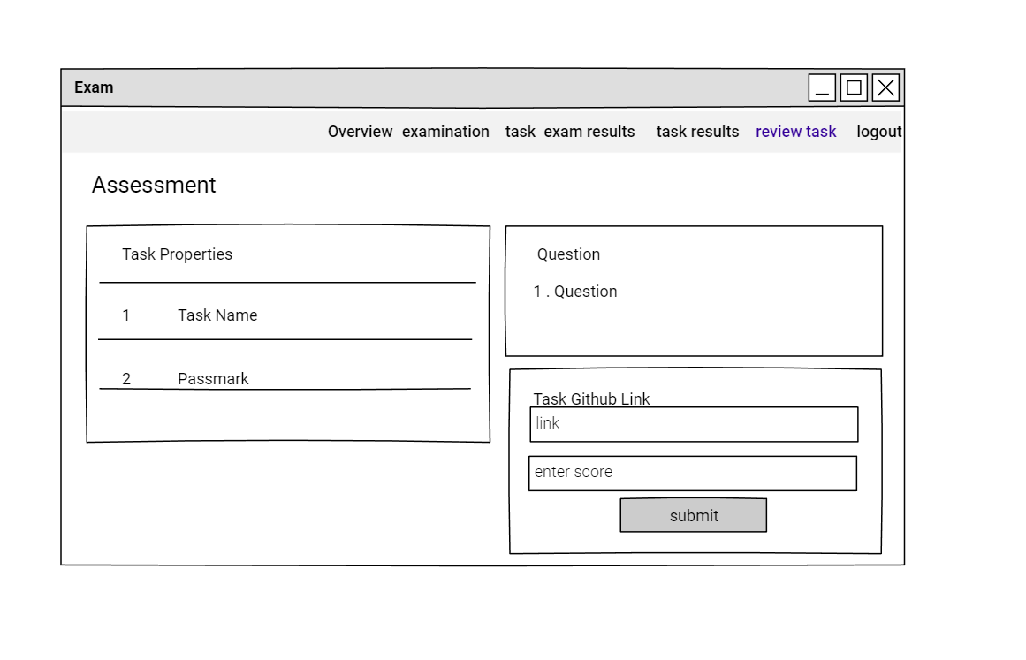

**USER VIEW EXAM RESULT**

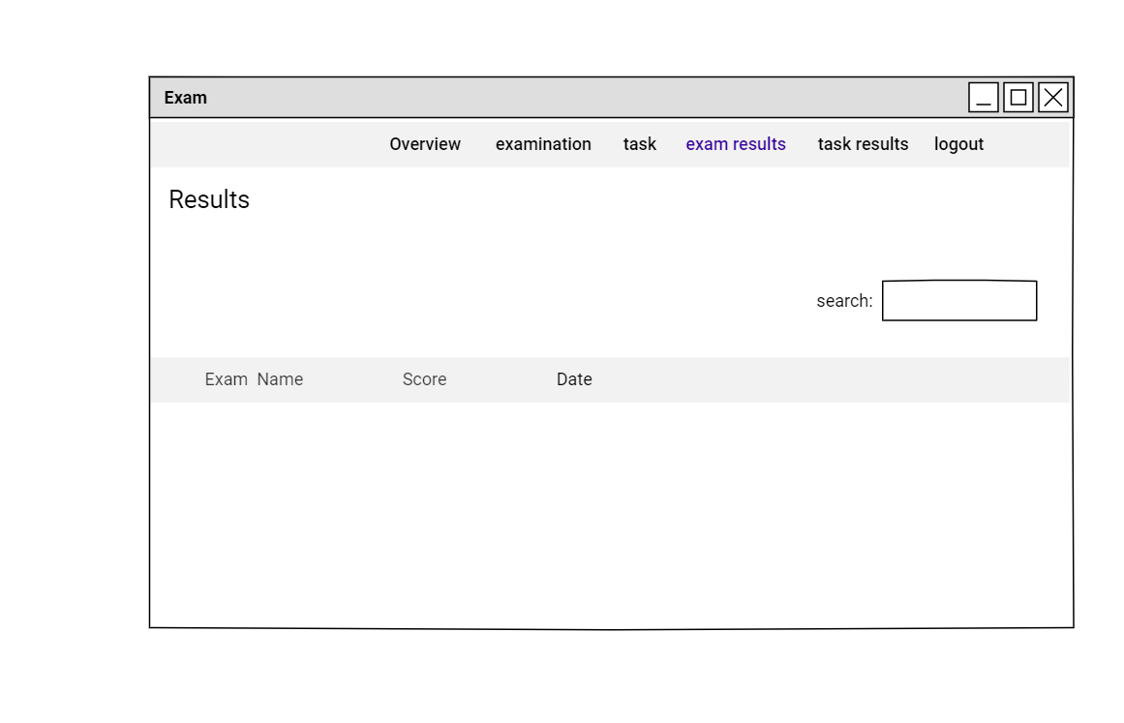

**USER VIEW TASK RESULT**

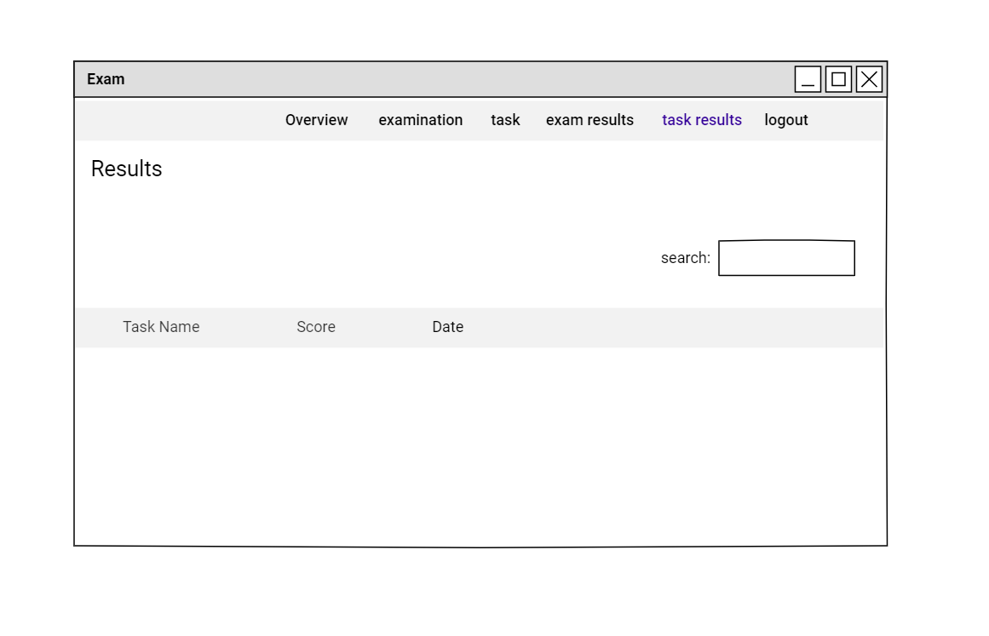

**COMPANY EXAM OVERVIEW**

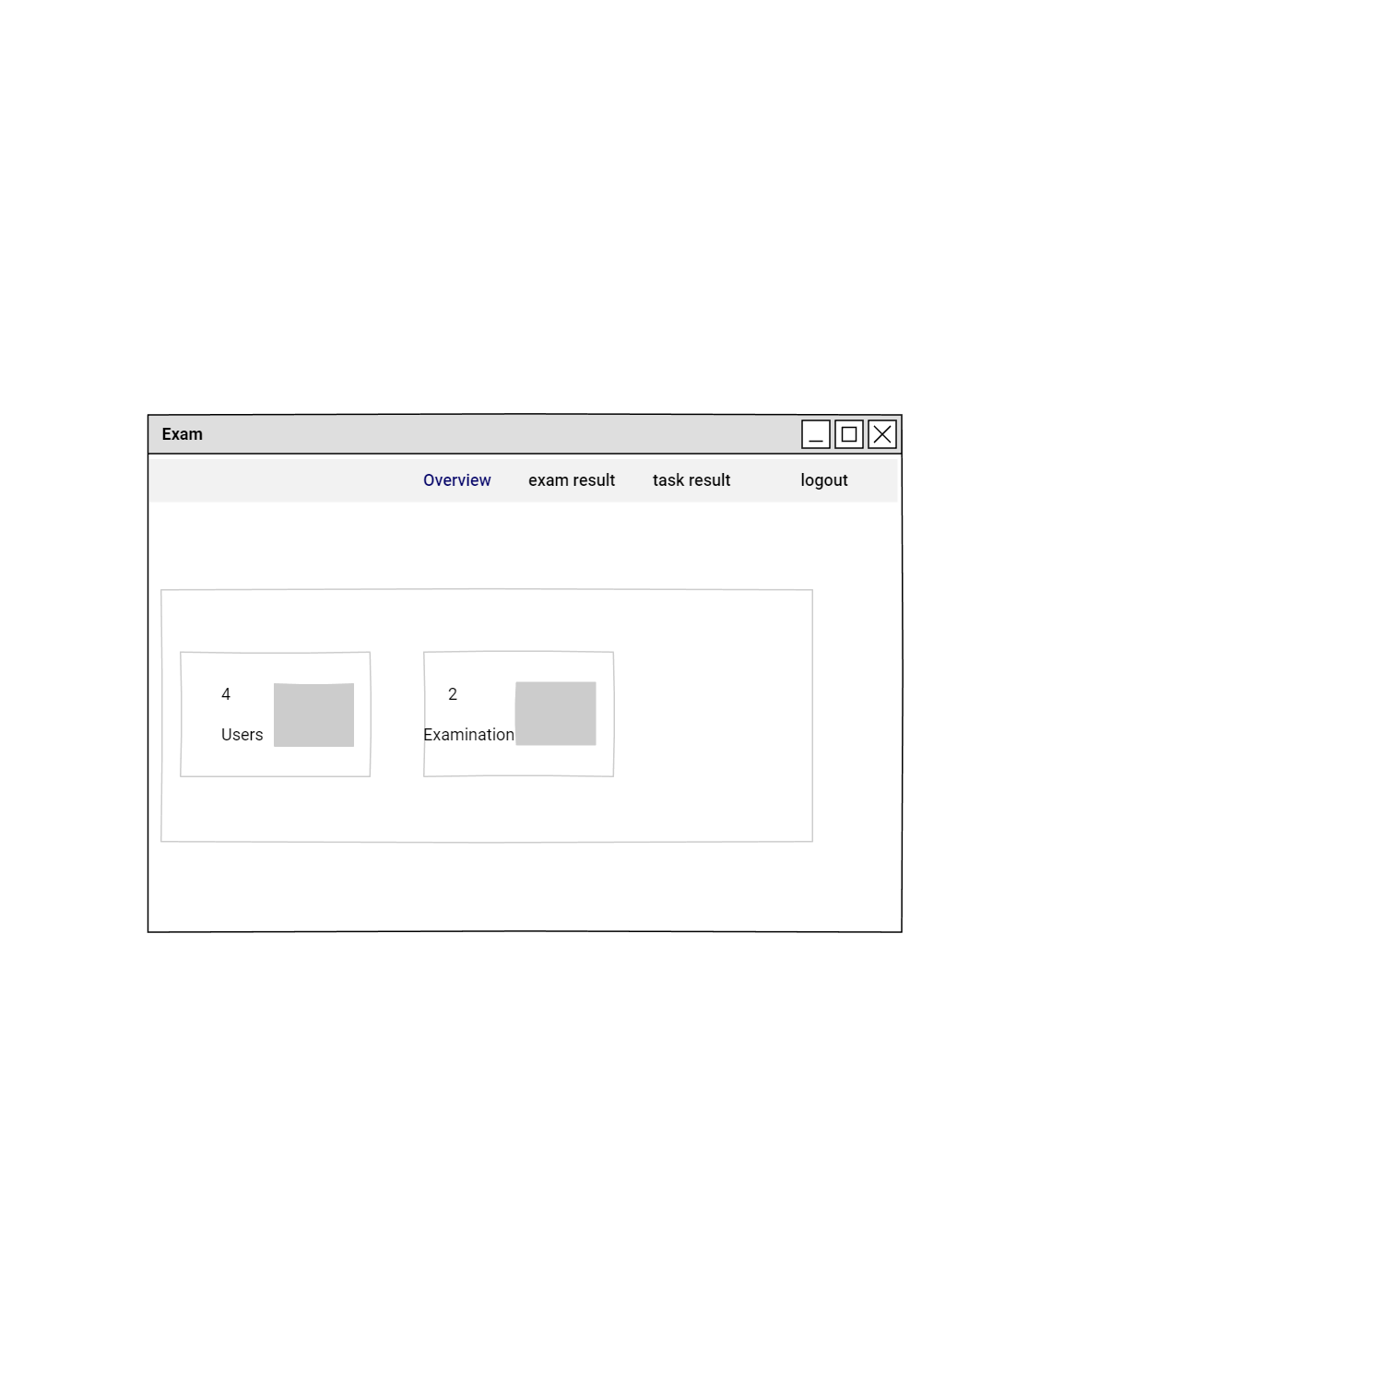

**COMPANY VIEW EXAMS RESULTS**

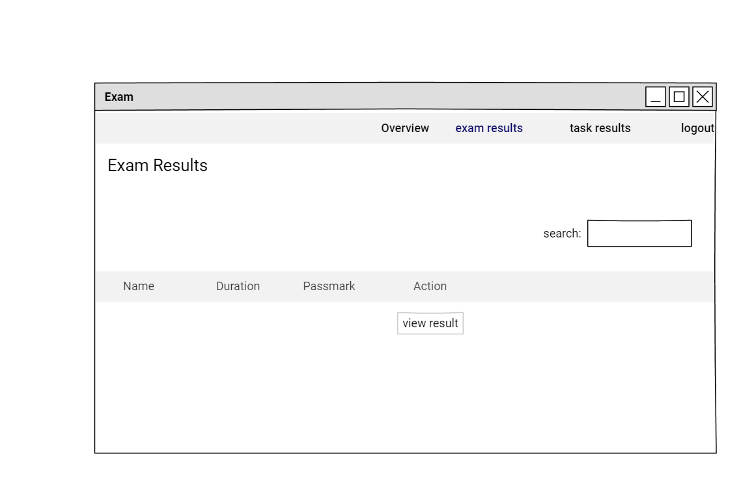

**COMPANY VIEW PARTICULAR EXAM RESULTS**

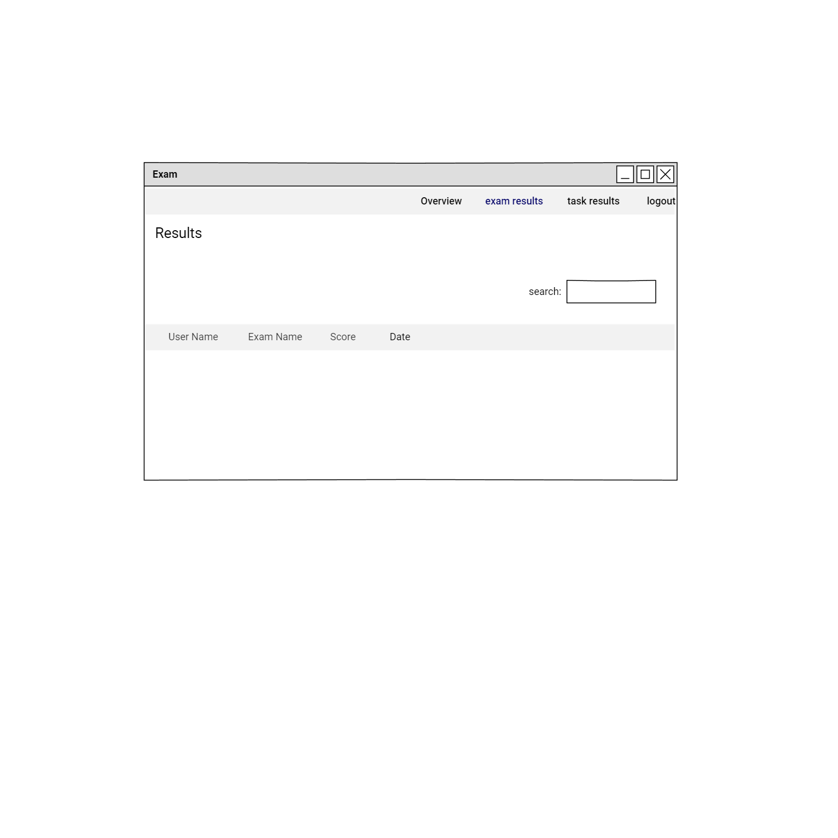

**COMPANY VIEW TASKS RESULTS**

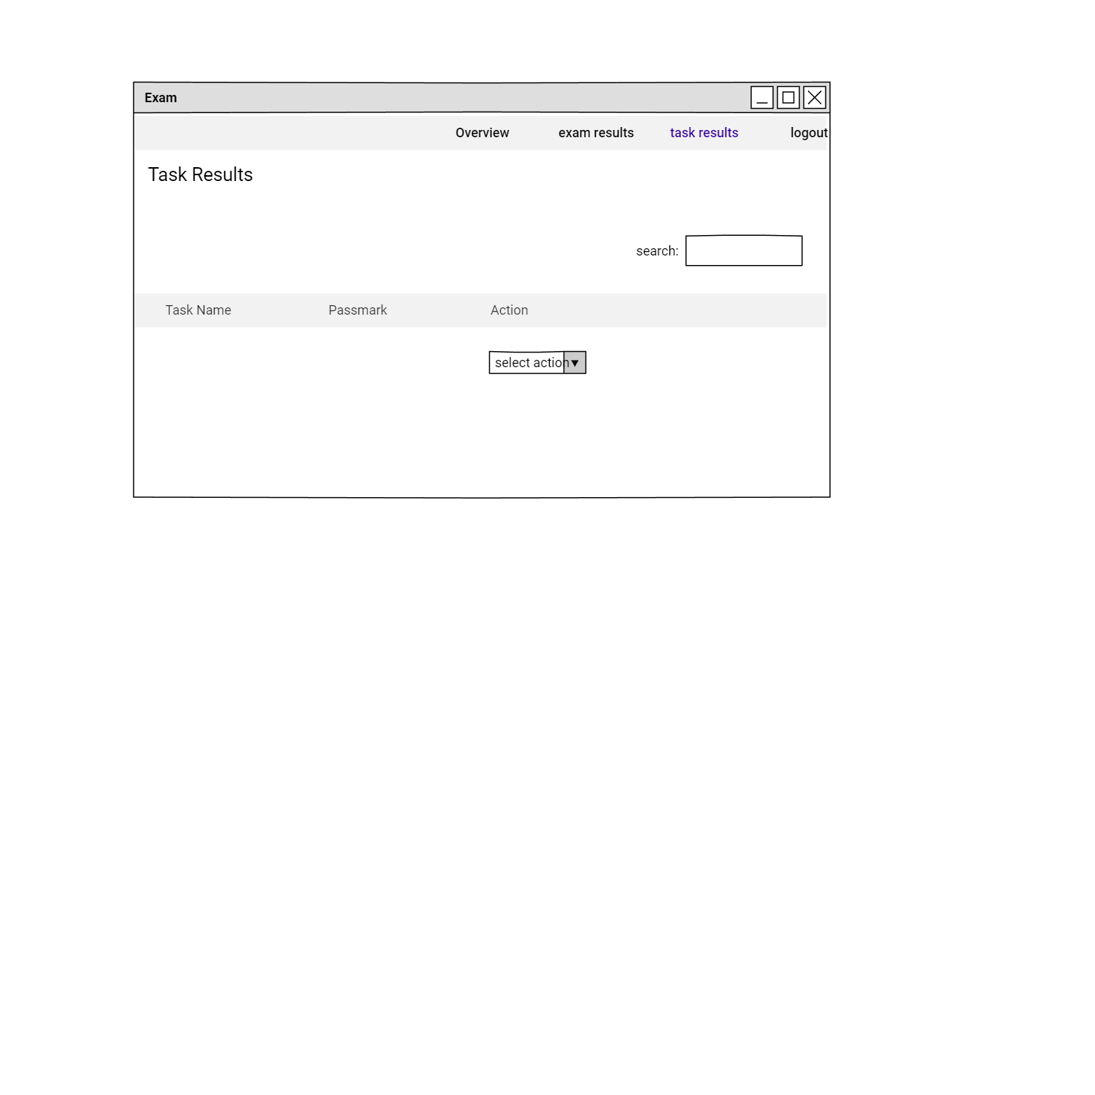

**COMPANY VIEW PARTICULAR TASK RESULTS**

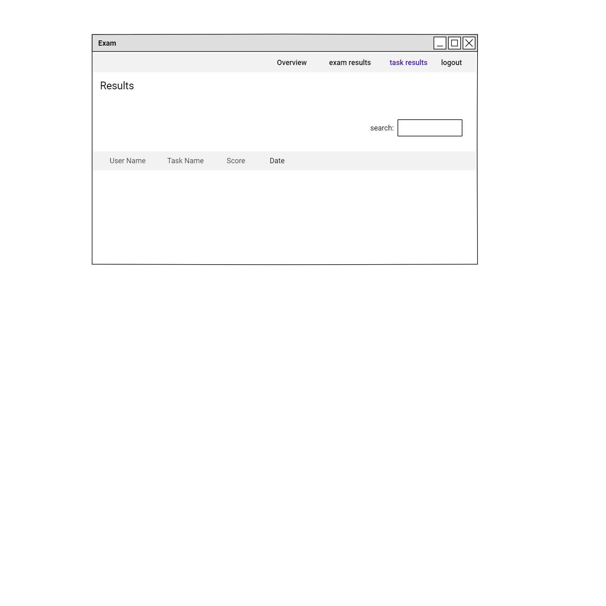

**TESTING & VALIDATIONS**

**SPRINT 1**

|  |  |  |  |  |  |
| --- | --- | --- | --- | --- | --- |
| **No.** | **Date** | **Action** | **Expected Result** | **Actual Result** | **Pass?** |
| 1 | 15-09-2020 | Home page | Admin/Company/  Candidates can view the type of services. | Admin/Company/Candidates can view the type of services. | Yes |
| 2 | 18-09-2020 | Registration | Company/Candidates should be able to register | Company/Candidates should be able to register | Yes |
| 3 | 20-09-2020 | Login | Users of the system can able to login to the system | Users of the system can able to login to the system | Yes |
| 4 | 23-09-2020 | View companies | Admin can view the companies register in the system | Admin can view the companies register in the system | Yes |
| 5 | 27-09-2020 | Approve/Disapprove Company | Admin can approve or reject or reactivate company registration | Admin can manage company registration | Yes |

**SPRINT 2**

|  |  |  |  |  |  |
| --- | --- | --- | --- | --- | --- |
| **No.** | **Date** | **Action** | **Expected Result** | **Actual Result** | **Pass?** |
| 1 | 30-09-2020 | Post Jobs | Employer can post job vacancies in their company | Employer can post job vacancies in their company | Yes |
| 2 | 04-10-2020 | View and Delete Jobs | Admin can view and delete job post | Admin can view and delete job post | Yes |
| 3 | 10-10-2020 | Search,View,Apply jobs and View Applied Job Applications | Users can view,  search and apply for jobs | Users can view, search and apply for jobs | Yes |
| 4 | 11-10-2020 | View Posted Jobs | Companies can view and delete their posted job vacancies | Companies can view and delete their posted job vacancies | Yes |

**SPRINT 3**

|  |  |  |  |  |  |
| --- | --- | --- | --- | --- | --- |
| **No.** | **Date** | **Action** | **Expected Result** | **Actual Result** | **Pass?** |
| 1 | 14-10-2020 | View Job Applications And Download resumes | Employer can view job application for their job post applied | Employer can view job application for their job post applied | Yes |
| 2 | 19-10-2020 | Create Exams | Admin can create exam, add questions and also manage created exams. | Admin can create exam, add questions and also manage created exams | Yes |
| 3 | 22-10-2020 | Create Tasks | Admin can create Tasks, add questions and also manage created tasks. | Admin can create Tasks, add questions and also manage created tasks. | Yes |
| 4 | 30-10-2020 | Attend Exam | User can attend  exams. | User can attend  exams. | Yes |

**SPRINT 4**

|  |  |  |  |  |  |
| --- | --- | --- | --- | --- | --- |
| **No.** | **Date** | **Action** | **Expected Result** | **Actual Result** | **Pass?** |
| 1 | 31-10-2020 | View candidates | Admin can view registered candidates details. | Admin can view registered candidates details. | Yes |
| 2 | 04-11-2020 | Attend Task | User can submit task | User can submit task | Yes |
| 3 | 11-11-2020 | View Exam,Task Scores,Review tasks | Admin/user/company can view candidate’s exam and task scores. | Admin/user/company can view candidate’s exam and task scores. | Yes |
| 4 | 13-11-2020 | Send/Receive Messages | user/ company can send or receive messages. | User/ company can send or receive messages. | Yes |
| 5 | 15-11-2020 | Update profile and change password | user/company can update their profile and can change password. | user/company can update their profile and can change password. | Yes |

**SCRUM REVIEW**

**SPRINT 1**

|  |  |  |  |
| --- | --- | --- | --- |
| **No.** | **User Story ID** | **Date** | **Comments From Scrum Master If Any** |
| 1 | 1  2  3 | 23-09-2020 | satisfied   * Done proper validation for password * Change country,state and city fields into select box * Add terms and conditions * Check DOB valid or not   satisfied |
| 2 | 4,5 | 26-09-2020 | satisfied |

**SPRINT 2**

|  |  |  |  |
| --- | --- | --- | --- |
| **No.** | **User Story ID** | **Date** | **Comments From Scrum Master If Any** |
| 1 | 6,7 | 03-10-2020 | Satisfied |
| 2 | 8  9 | 10-10-2020 | * Remove search button   satisfied |

**SPRINT 3**

|  |  |  |  |
| --- | --- | --- | --- |
| **No.** | **User Story ID** | **Date** | **Comments From Scrum Master If Any** |
| 1 | 10,11 | 17-10-2020 | Satisfied |
| 2 | 12 | 24-10-2020 | Satisfied |
| 3 | 13 | 02-11-2020 | There is no need to show the exam details that the candidate already attend. |

**SPRINT 4**

|  |  |  |  |
| --- | --- | --- | --- |
| **No.** | **User Story ID** | **Date** | **Comments From Scrum Master If Any** |
| 1 | 14,15 | 02-11-2020 | satisfied |
| 2 | 16,17,18 | 16-11-2020 | satisfied |

**SPRINT REVIEW**

**SPRINT 1**

|  |  |  |  |
| --- | --- | --- | --- |
| **Date** | **User Story ID** | **Comments from scrum master if any** | **Comments from Product owner if any** |
| 28-09-2020 | 1,3,4,5  2 | Satisfied  completed | satisfied   * Data enter in registration form must preserve whenever an error occure during the form validation time. |

**SPRINT 2**

|  |  |  |  |
| --- | --- | --- | --- |
| **Date** | **User Story ID** | **Comments from scrum master if any** | **Comments from Product owner if any** |
| 13-10-2020 | 1,2,3,4 | Satisfied | Satisfied |

**SPRINT 3**

|  |  |  |  |
| --- | --- | --- | --- |
| **Date** | **User Story ID** | **Comments from scrum master if any** | **Comments from Product owner if any** |
| 04-11-2020 | 10,11,12  13 | Satisfied  completed | satisfied  Remove user id,user name and status in user view exam result. |

**SPRINT 4**

|  |  |  |  |
| --- | --- | --- | --- |
| **Date** | **User Story ID** | **Comments from scrum master if any** | **Comments from Product owner if any** |
| 18-11-2020 | 14,15,16,17,18 | satisfied | satisfied |

**VERSION DETAILS**

**VERSION TABLE IN GIT**

|  |  |  |
| --- | --- | --- |
| **User Story ID** | **Status** | **Date Uploaded** |
| 1 | COMPLETED | 15-09-2020 |
| 2 | COMPLETED | 17-09-2020 |
| 3 | COMPLETED | 22-09-2020 |
| 4 | COMPLETED | 25-09-2020 |
| 5 | COMPLETED | 27-09-2020 |
| 6 | COMPLETED | 30-09-2020 |
| 7 | COMPLETED | 03-10-2020 |
| 8 | COMPLETED | 10-10-2020 |
| 9 | COMPLETED | 11-10-2020 |
| 10 | COMPLETED | 14-10-2020 |
| 11 | COMPLETED | 19-10-2020 |
| 12 | COMPLETED | 24-10-2020 |
| 13 | COMPLETED | 30-10-2020 |
| 14 | COMPLETED | 31-10-2020 |
| 15 | COMPLETED | 04-11-2020 |
| 16 | COMPLETED | 11-11-2020 |
| 17 | COMPLETED | 13-11-2020 |
| 18 | COMPLETED | 15-11-2020 |

